Do They Watch Too Much?
Part A

Data Management
Unit 1B Line Master 5a

Three Grade 4 students recorded their screen times for one week.
Here are their data shown two ways.
Day | 1 | 2 | 3 | 4 | 5 | 6 | 7
Tasneem | 8 | 9 | 7 | 5 | 6 | 3 | 4
Marceline | 6 | 7 | 8 | 9 | 9 | 0 | 3
Andre | 6 | 8 | 7 | 6 | 5 | 1 | 2

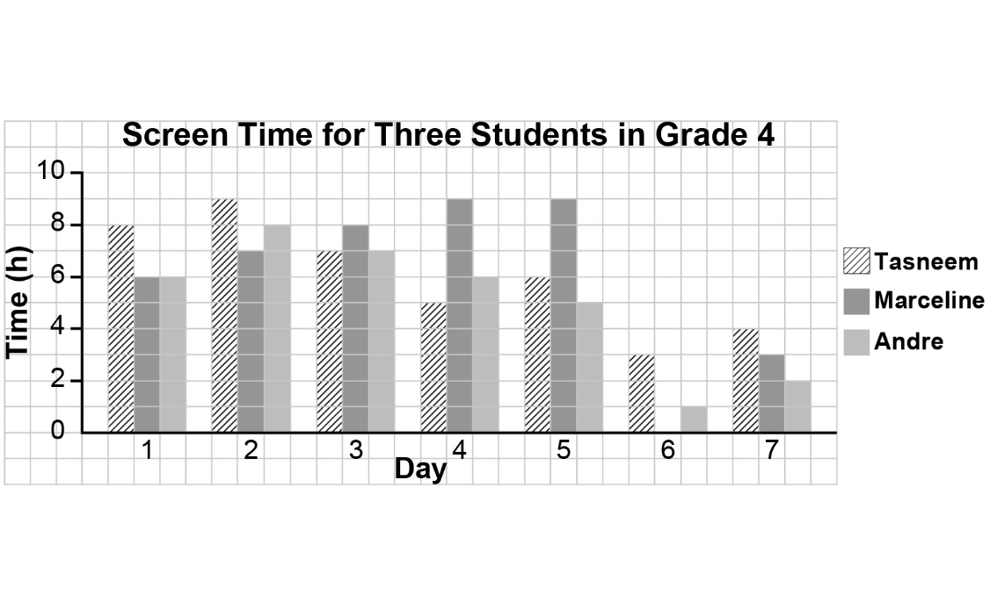

Do They Watch Too Much? (cont’d)
Part B

Data Management
Unit 1B Line Master 5b

Students in a Grade 4 class used a stem-and-leaf plot to record
their screen time, in hours, for one week.

Weekly Screen Time for Students in a Grade 4 Class (h)

Stem | Leaf
0 | 5 5
1 | 5 8 8 9 9
2 | 5 5 6 6 6 8 8 9 9
3 | 0 1 1 2 5 7
4 | 0 2 2 5
Key: 0|5 means 5 h

