“Data” Challenge
Part A

Data Management
Unit 1B Line Master 2a

Results of Our Class (Class A)
Number of Times | Tally
0–9
10–19
20–29
30–39
40–49

Are your data primary or secondary?
Is it qualitative or quantitative?

“Data” Challenge (cont’d)
Part B

Data Management
Unit 1B Line Master 2b

Results of Class B
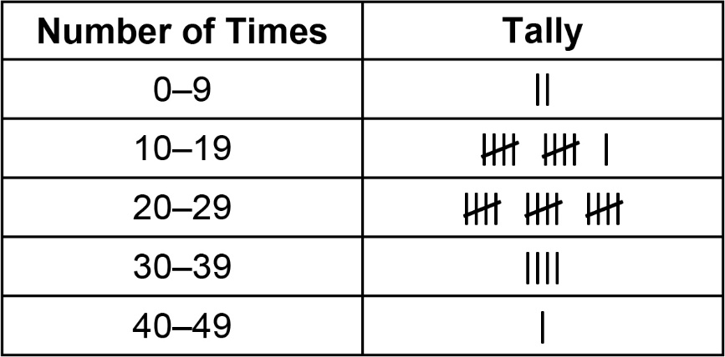

Are the data primary or secondary?
Compare with the results from your class.

“Data” Challenge (cont’d)
Part C

Data Management
Unit 1B Line Master 2c

Here are the data collected by the students in another class:
8, 30, 9, 11, 32, 31, 12, 14, 31, 25, 30, 15, 27, 10, 28,
22, 13, 3, 26, 17, 18, 32, 16, 24, 13, 10, 8, 7, 26, 22, 15

Organize the data in the frequency table.

Results of Class C
Number of Times | Tally
0–9
10–19
20–29
30–39
40–49

Are the data primary or secondary?

“Data” Challenge (cont’d)

Data Management
Unit 1B Line Master 2d

Compare the data from your class (Class A), Class B, and Class C.
What conclusions can you make?

