Analyzing and Classifying 2-D Shapes and Using Algebraic Thinking
Reads and alters code by testing out various values or blocks until desired outcome is attained.  “I’m going to change the steps to 50 and the wait to 2 and the degrees to 90.” | Reads and alters code by visualizing and explaining the impact of changes until desired outcome is achieved.  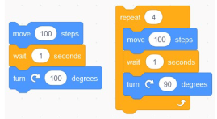  “I’ll change the steps to 50, the degrees to 90, and I’ll delete the wait because it doesn’t impact the end image, only how long it takes to make. And I can just repeat 4 times to get a square.” | Reads and flexibly alters code, including an ability to alter the same code in different ways for the same desired outcome.  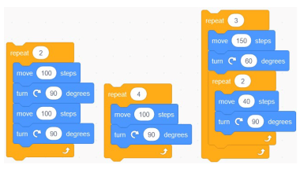  “I’m going to alter this to use fewer blocks. Since the actions are equal in both code sequences, the outcome will be the same.” Or “This nested loop is another way to create this design without so many blocks.”
Observations/Documentation

Analyzing and Classifying 2-D Shapes and Using Algebraic Thinking (cont’d)
Uses basic blocks to write code for a desired outcome  “I tried using these blocks in this order, but it didn’t make what I wanted.” | Uses more complex blocks (including repeat) to write code for a desired outcome  “I wrote code, but it used so many blocks. I can see that these blocks repeat. So, I used the repeat block instead and deleted these other blocks.” | Uses complex blocks to flexibly write different code for the same desired outcome  “Coding and algebra are very connected. Comparing the code sequences in these blocks is like comparing equivalent expressions. As long as the final outcome is the same, there are many code sequences that can create it.”
Observations/Documentation

