Solving Inequalities
Recognizes inequality symbols and their meaning in various inequality equations  m > 6  m $≥$ 6  “Each time, the unknown can be any number greater than 6. In the second equation, it could also be 6. There are many quantities that would work.” | Represents solutions to simple inequalities by graphing on a number line and testing solutions.  $$∎+3≤10 \\ ∎≤7$$  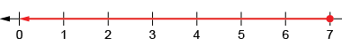  “The unknown plus 3 needs to be less than or equal to 10. I could count on 7 from 3 to get 10.  So, I know the unknown  must be 7 or less.” | Uses inverse operations to re-write inequalities, then solves.  $$∎+3≤10$$  $$∎≤10- 3$$  “I am going to verify by choosing 2 | Flexibly solves inequalities, then verifies and graphs the solutions.  18 – m < 8  “What numbers can I take away from 18 for the answer to be less than 8?”  I can rearrange the equation to find the unknown: 18 – 8 < m  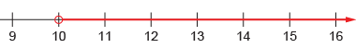
Observations/Documentation

