Pattern Relationships
Recognizes number pattern relationships  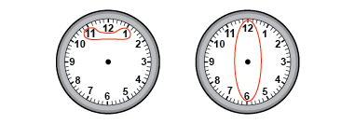  “I see number relationships on the clock:  pairs of numbers on a horizontal line add to 12: 11 + 1 = 12, 10 + 2 = 12; and opposite numbers have a difference of 6: 12 - 6 = 6, 7 – 1 = 6.” | Identifies patterns and relationships in a chart, table, or diagram  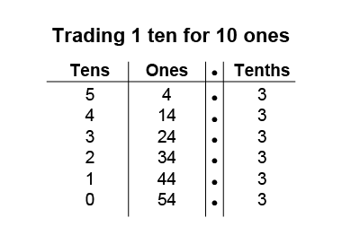  “I noticed that 54.3 can be written as a sum,  in different ways, to form a pattern  by trading 1 ten for 10 ones.” | Describes patterns to illustrate the relationships among whole numbers and decimal numbers  0.8 + 4.0 = 4.8  0.7 + 4.1 = 4.8  0.6 + 4.2 = 4.8  0.5 + 4.3 = 4.8  0.4 + 4.4 = 4.8  “The pattern shows that as one addend increases by 0.1, the other addend decreases by 0.1, so the sum stays the same.”
Observations/Documentation

Pattern Relationships (cont’d)
Describes pattern relationships found in a table or diagram using addition or subtraction  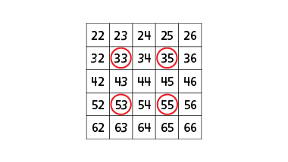  “When I added the numbers on the diagonals in squares formed by 4 numbers on the hundred chart, I noticed the sums are equal. It happened when I choose different numbers too.” | Describes pattern relationships on tables, charts, or diagrams using multiplication  9, 18, 27, 36, 45, 54, 63, 72, 81, 90  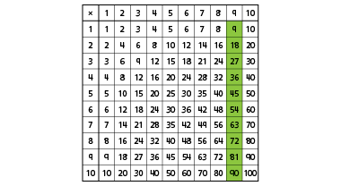  “These are the products from 9 × 1 to 9 × 10. The ones digits decrease by 1 each time, and the tens digits increase by 1 each time. The sum of the digits in each product is 9.” | Fluently identifies and describes different patterns in a variety of representations  1, 4, 9, 16, 25, 36, 49, 64, 81, 100  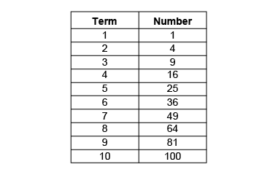  “When looking at the products I identified several pattern relationships and rules:  multiply each number by itself or start at  1, add 3, add 5, add 7, … or start at 1, add 3,  then add 2 more than you added the time before.”
Observations/Documentation

