Generalizing and Representing Patterns
Recognizes that a pattern can repeat, increase, or decrease.  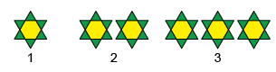  “This is an increasing pattern. I know this because each time there are more blocks.” | Identifies how a pattern changes and describes the pattern rule.  “The pattern rule is: Start with 1 hexagon and 6 triangles. Add one hexagon and 6 triangles each time.” | Represents patterns using a table  or chart.  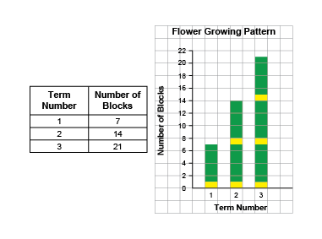  “The table shows the number of blocks increases by 7 each time, and the graph shows the height of the bars increases by  the same amount.”  Term Number Number of Blocks  1 8  2 16  3 24 | Represents patterns symbolically and writes the pattern rule.  7, 14, 21  “The number of blocks in each term increases by 7 because  each flower has 7 blocks.  Term 3: 7 + 7 + 7 = 21.”
Observations/Documentation

Generalizing and Representing Patterns (cont’d)
Extends patterns using repeated addition, repeated subtraction, or multiplication.  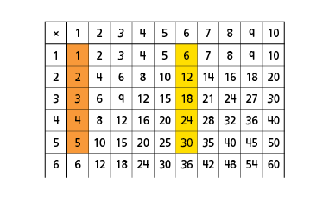  “I extended the patterns in the number of hexagons and triangles using a multiplication chart.” | Creates patterns and explains the pattern rule.  23, 31, 39, 47, 55, 63, 71, 79, 87, 95  “I created an increasing pattern that starts at 23 and increases  by 8 each time.” | Uses patterns to solve problems.  Yasmin and her family are planning a celebration and need to arrange 70 chairs.  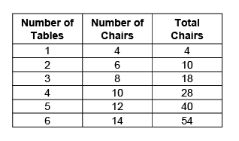  “I added the number of chairs in the first 6 terms (54).  Term 7 is 16 and 54 + 16 = 70.  Yasmin will need 7 tables.” | Fluently identifies, creates, and extends patterns to solve real-life problems.  Sami takes 40 minutes to make one bracelet. How many bracelets can Sami make in 6 hours?  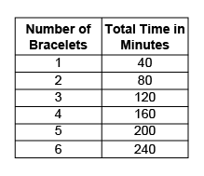  “There are 360 minutes in 6 hours.  I know that the pattern increases by 40 mins each term. 9 × 40 = 360. Sami can make 9 bracelets  in 6 hours.”
Observations/Documentation

