Relationship Between Repeated Addition of Unit Fractions and Multiplication
Counts unit fractions  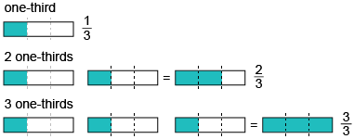  “1 one-third, 2 one-thirds,  3 one-thirds” | Concretely solves problems involving the repeated addition of unit fractions  Miranda feeds her puppy, Atlas,  $\frac{1}{3}$ cup of food, 4 times per day.  How much food does the puppy get in two days?  “1 one-third, 2 one-thirds, 3 one-thirds, 4 one-thirds, 5 one-thirds, 6 one-thirds, 7 one-thirds,  8 one-thirds”  $\frac{8}{3}$ cups = 2$\frac{2}{3}$ cups | Models symbolically and describes repeated addition of unit fractions  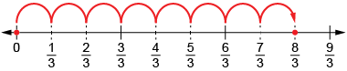  $\frac{1}{3}$ + $\frac{1}{3}$ + $\frac{1}{3}$ + $\frac{1}{3}$ + $\frac{1}{3}$ + $\frac{1}{3}$ + $\frac{1}{3}$ + $\frac{1}{3}$ = $\frac{8}{3}$  $\frac{8}{3}$ = $\frac{6}{3}$ + $\frac{2}{3}$ = 2$\frac{2}{3}$  “Atlas gets 2$\frac{2}{3}$ cups  of food per day.” | Uses multiplication of unit fractions to flexibly solve related problems  Atlas is fed 4 times per day  for 2 days: 4 × 2 = 8  8 × $\frac{1}{3}$ = $\frac{8}{3}$, or 2$\frac{2}{3}$  “Atlas gets 2$\frac{2}{3}$ cups of food.”
Observations/Documentation

