Conceptual Meaning of Addition and Subtraction of Decimals
Recognizes addition and subtraction situations and models concretely to add or subtract to tenths  0.7 + 0.8 = 1.5  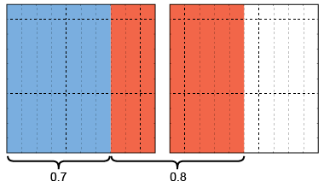  “7 tenths + 8 more tenths = 1 whole and 5 tenths” | Models and symbolizes ways to solve problems by using a number line  1.5 – 0.7 = ?  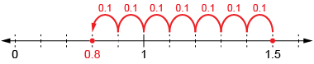 | Uses an understanding of place value to add or subtract decimals with tenths (decomposes both numbers)  14.6 + 27.8 = ?  14 + 27 = 41 (whole numbers)  0.6 + 0.8 = 1.4 (decimals)  41 + 1.4 = 42.4  “I decomposed both numbers,  added the whole numbers, then the tenths.”
Observations/Documentation

Conceptual Meaning of Addition and Subtraction of Decimals (cont’d)
Uses an understanding of place value to decompose one number  14.6 + 27.8 = ?  27.8 = 27 + 0.8  14.6 + 27 = 41.6  41.6 + 0.8 = 42.4  “I used place value to  add on the second number.” | Uses estimation and mental math strategies to check reasonableness of solutions  25.86 – 17.23 = 8.63  26 – 17 = 9  “8.63 is the answer I calculated,  and it is close to 9,  so my answer is reasonable.” | Solves addition and subtraction problems flexibly, using a variety of strategies  25.85 – 17.21 = ?  25.85 + 0.15 = 26  17.21 + 0.15 = 17.36  26 – 17.36 = 8.64
Observations/Documentation

