Conceptual Meaning of Multiplication and Division with Larger Numbers
Models multiplication and division situations concretely and pictorially  6 × 287 = ?  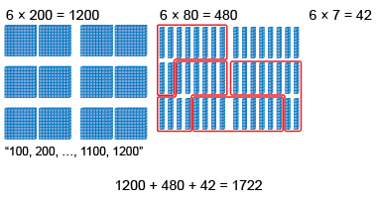  “I traded groups of 10 rods for a flat.” | Models multiplication and division situations using open arrays.  6 × 287 = ?  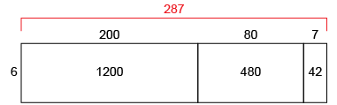  “I can use an open array to help me multiply.” | Uses place value to multiply whole numbers by 10, 100, and 1000 and to divide by 10.  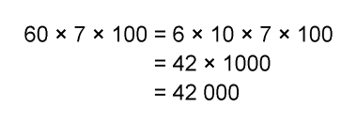  “I used the associative property  to make friendly numbers,  then used the known fact 6 × 7 = 42.”
Observations/Documentation

Conceptual Meaning of Multiplication and Division with Larger Numbers (cont’d)
Decomposes numbers and use partial products and partial quotients to multiply and divide.  6 × 287 = ?  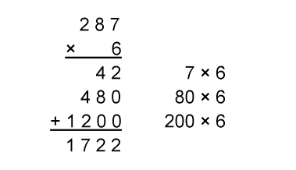  “I decomposed 287 into hundreds, tens, and ones, then used partial products to multiply.” | Estimates to determine if answer to multiplication or division problem is reasonable.  6 × 287 = 1722  287 is close to 300.  6 × 300 = 1800  1800 is close to the answer I calculate, 1722.  So, my answer is reasonable. | Creates and solves multiplication and division problems flexibly using a variety of strategies.  123 ÷ 6 =?  “I counted 123 photographs to put in an album. Each page can hold 6 photographs. How many pages will I need?”  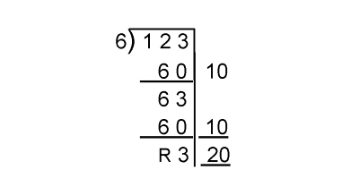  “I round up to 21 pages to be sure  all photos will fit.”
Observations/Documentation

