Fluency of Multiplication and Division Facts
Recalls and demonstrates multiplication and divisions facts  to 5 × 5.  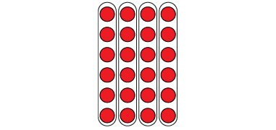  “I know that 4 × 6 = 24  and that 24 ÷ 6 = 4.  The array shows both facts.” | Uses inverse operations to solve multiplication and division problems.  “I can rewrite 24 ÷ 6 = ?  as 6 × ? = 24.” | Uses known facts to determine unknown facts  “I can use the distributive property to split the multiplication into facts that I know, then add.”  5 × 9 = 5 × 5 + 5 × 4  25 + 20 = 45  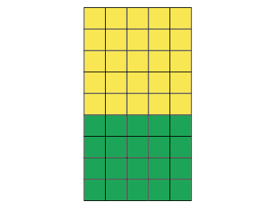 | Fluently creates and solves whole number multiplication and division problems.  There are 56 basketballs with the same number on each of 8 shelves.  8 × □ = 56, so 56 ÷ 8 = □  8 × 7 = 56  Or  8 × 7 = 4 × 7 + 4 × 7  = 28 + 28  = 56  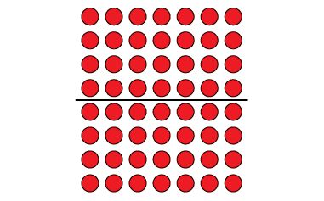
Observations/Documentation

Representing Multiplicative Relationships as Rates
Solves unit rate problems concretely and pictorially  It takes 6 apples to make an apple pie. How many apples are needed to make 9 pies?  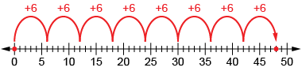  “I used a number line to show how the number of apples increases as the number of pies increases.” | Uses various tools to solve multiple unit rate problems.  Kiran and Simi walk 30 km. Kiran walks 5 km per hour and Simi walks 6 km in one hour. How long will it take each person to walk 30 km?  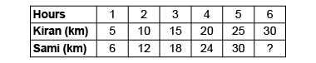  “I used a ratio table. It makes it easy to make comparisons and to solve the problem.” | Uses inverse relationships to record and solve unit rate problems  Marc paddled a canoe 10 km in 150 minutes. At what rate did he paddle?  “10 km × rate per minute = 150 minutes  I thought division: 150 ÷ 10 = ?  I know 10 × 15 = 150.  So, Marc paddled at the  rate of 15 km per minute.” | Flexibly applies multiplicative reasoning to solve different types of unit rate problems.  Shila cuts lawns in the neighborhood and charges $7/hour. If Shila works for 6 hours each week, how many hours will Shila need to work to make $168?  “I know that Shila makes $42 a week (7 × 6 = 42). From the ratio table, Shila will make $168 dollars after 24 hours of work.”
Observations/Documentation

