Exploring Decimals
Demonstrates how decimals can be equally partitioned into tenths and hundredths  “The large square is one whole. It has ten equal-sized rows. Each row is one-tenth.” | Relates visual representation of decimal with tenths to place value  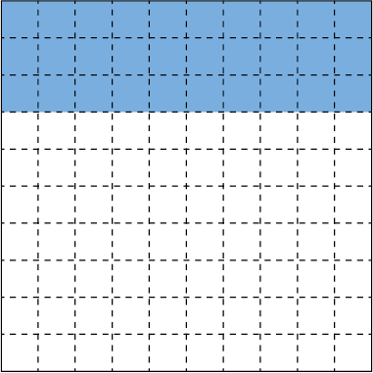  “0.3; the digit in the tenth place is 3  because there are three tenths shaded.” | Compares and orders decimals with tenths using a variety of strategies (e.g., benchmarks, grids)  “1.9 > 1.6: both decimals have 1 whole, so I compare the tenths. Nine tenths is greater than 6 tenths, so 1.9 is greater.”
Observations/Documentation

Exploring Decimals (cont’d)
Rounds decimals with tenths to the nearest whole number  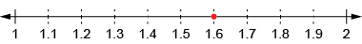  “1.6 is 4 tenths away from 2 and 6 tenths away from 1. So, 1.6 is closer to 2.” | Relates visual representation of decimal with hundredths to place value  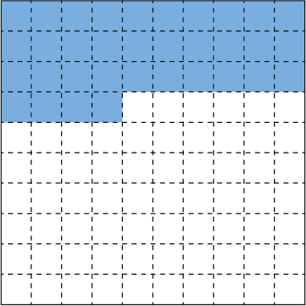  “0.34 represents 3 tenths and 4 hundredths, or 34 hundredths.” | Recognizes and writes equivalent decimals  “0.2 = 0.20  2 tenths = 20 hundredths”
Observations/Documentation

