Conceptual Meaning of Whole Number Addition and Subtraction
Recognizes addition and subtraction situations and models concretely to add or subtract to 1000  148 + 223 = ?  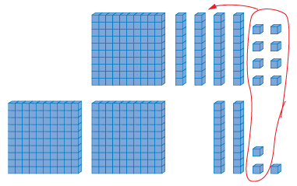 | Models and symbolizes ways to solve problems to 1000  148 + 223 = ?  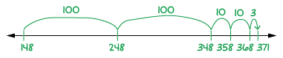 | Uses an understanding of place value to decompose both numbers to solve problems to  10 000  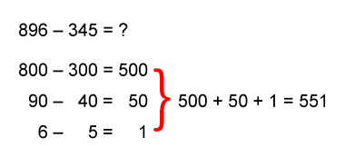  “I subtracted the hundreds, the tens,  and then the ones.”
Observations/Documentation

Conceptual Meaning of Whole Number Addition and Subtraction (cont’d)
Uses an understanding of place value to decompose one number to solve problems to 10 000  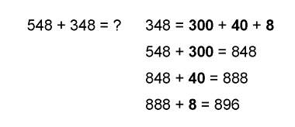  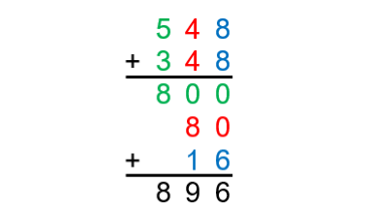  “I used place value to  add on the second number.” | Estimates to determine if answer to problem is reasonable  896 - 345 = ?  “896 is close to 900. 345 is close to 350.  900 - 350 = 550. 550 is close to 551, the answer I calculated, so my answer is reasonable.” | Creates and solves addition and subtraction problems flexibly using a variety of strategies  1874 raffle tickets were sold in advance. 227 more tickets were sold at the door. How many tickets were sold altogether?
Observations/Documentation

Developing Fluency of Whole Number Addition and Subtraction
Uses known sums and differences to fluently solve addition and subtraction problems to 100  25 + 76 = ?  “I know 25 + 75 = 100. Since 76 is 1 more than 75, the answer is 101.” | Purposefully uses properties or relationships to solve addition and subtraction problems  25 + 44 + 76 = ?  “I can rearrange the numbers  to make it easier to add.”  25 + 76 + 44 = 101 + 44  = 145 | Understands the inverse relationship between addition and subtraction and applies it  to solve problems  645 – 227 = ?  “I can rewrite it as an addition problem:  227 + ? = 645.  I can use friendly numbers.  200 + 400 = 600 and 27 + 18 = 45.  The missing part is 400 + 18 = 418.  Check: 227 + 418 = 645.”
Observations/Documentation

Developing Fluency of Whole Number Addition and Subtraction (cont’d)
Applies mental strategies and algorithms to add and subtract (e.g. using benchmark numbers, known facts, partial sums)  227 + 418 = __  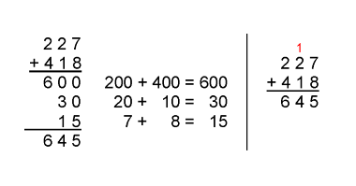  “I could used partial sums  or the standard algorithm.” | Uses estimation to check the reasonableness of solutions  This year 227 children, 34 teachers, and 18 supervisors will attend the local fair. How many people will attend altogether?  “227 is close to 230, 34 is close to 35, and 18 is close to 20. 230 + 35 + 20 = 285. I overestimated because we want to make sure we have enough buses.” | Flexibly creates and solves addition and subtraction problems and checks reasonableness of solutions  185 students were to attend the assembly. 27 students were absent form school. How many students attended the assembly?  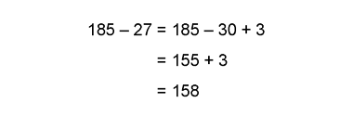  “190 - 30 = 160. Since 160 is close to 158, solution is reasonable.”
Observations/Documentation

