Comparing and Ordering Quantities
Models numbers and compares blocks  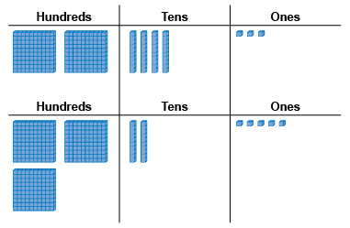  “325 has one more hundred flat,  so it is greater than 243.” | Compares numbers with benchmarks  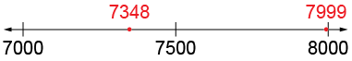  “I compared the numbers to 7500. 7348 is less than 7500 and 7999 is almost 8000.  So, 7999 is greater.” | Visualizes benchmarks on a number line to compare  “I picture 7999 farther to the right on the line than 7348. So, 7999 is greater than 7348.”
Observations/Documentation

Comparing and Ordering Quantities (cont’d)
Uses place value understanding to compare numbers, digit by digit  “Both start with 7.  3 hundreds is less than 9 hundreds,  4 tens is less than 9 tens,  and 8 ones is less than 9 ones.  So, 7348 is less than 7999.” | Compares and orders three or more numbers using a variety of strategies  5031 4008 7999 7438  “I first compare using thousands,  then compare 7999 and 7438 using hundreds.” | Compares numbers flexibly and records comparisons symbolically (<, =, >)  3467 > 3267  “Both numbers have 3 thousands,  but 3467 has more hundreds.”
Observations/Documentation

