Understanding Relationships Among Metric Units
Understands the relationship between grams and kilograms and millilitres and litres.  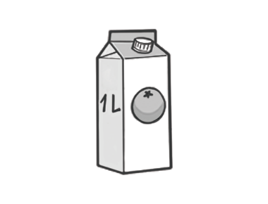  “A 1- L carton of juice  holds 1000 mL.” | Understands the relationships among metric units and uses them to convert between units.  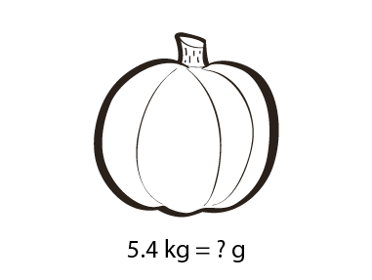  “I know that 1 kg = 1000 g.  1000 g + 1000 g + 1000 g + 1000 g + 1000 g = 5000 g,  and 0.4 kg = 400 g:  5000 g + 400 g = 5400 g.  The pumpkin’s mass is 5400 g.” | Applies the multiplicative relationships among metric units to convert between units.  Mika’s cousin weighed 4.13 kg at birth. How many decigrams did Mika’s cousin weigh?  “To convert kilograms to decigrams, multiply by 10 000: 4.13 × 10 000 = 41 300. Mika’s cousin weighed 41 300 dg.” | Flexibly and fluently uses the relationships among metric units to solve problems.  How many 325-mL containers could be filled from a 1-L bottle of mustard?  “I know that 325 × 3 = 975; 975 is close to 1000; 1 L = 1000 mL: 1000 mL - 975 mL = 25 mL. Three 325-mL containers could be filled and there would be 25 mL left over.”
Observations/Documentation

