Investigating Capacity
Identifies which metric unit should be used to measure the capacity of an object.  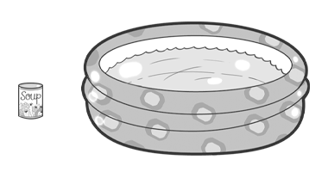  “I would use millilitres to measure the capacity of the can of soup and litres to measure the capacity of the swimming pool.” | Uses benchmarks to estimate capacity using metric units.  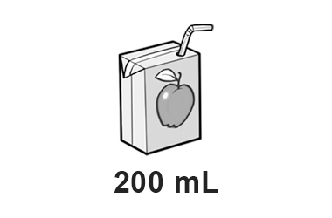  “I would estimate that it would take about 5 juice boxes to fill the jug, so the jug has a capacity of about 1 L because 5 × 200 mL = 1000 mL = 1 L.” | Chooses an appropriate metric unit to estimate and measure capacity of objects and explains reasoning.  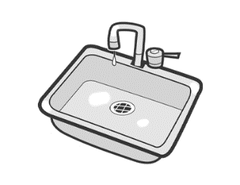  “I would use litres to measure the capacity of the sink because I know that the sink has a capacity much greater than that of a 1-L carton of milk.”
Observations/Documentation

Investigating Capacity (cont’d)
Explains the relationship between millilitres and litres and converts between units of measure.  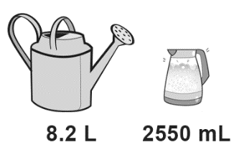  “I know 1000 mL = 1 L and 8.2 L = 1000 mL × 8.2, or 8200 mL. Since 8200 mL > 2550 mL, the watering can has the greater capacity.” | Compares and orders objects with capacities given in different units.  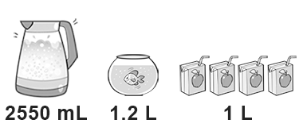  “I converted the capacity of the kettle to litres: 1 L = 1000 mL and 2550 mL = 2550 ÷ 1000 = 2.55 L.  The order from least to greatest capacity is juice boxes, fishbowl, kettle.” | Flexibly solves problems in various contexts where measures of capacity are given in different units.  How many 250 mL cups of water  will it take to fill a 2.75 L jug?  “I know 4 × 250 mL = 1000 mL; 8 × 250 mL = 2000 mL, and 250 mL × 3 = 750 mL; 2000 mL + 750 mL = 2750 mL; 8 + 3 = 11; It would take eleven 250 mL cups to fill the 2.75- L jug.”
Observations/Documentation

