Estimating and Investigating Area
Recognizes that area is measured using square units.  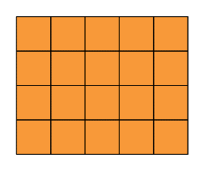  ”I covered the rectangle with square tiles and determined the area to be 20 square units.” | Uses referents to estimate area of regular and irregular shapes, then measures to check.  “I chose a square piece of newspaper as a referent for 1 m². I used the referent to estimate and measure the area of the blackboard. I estimated the area to be 25 m²  and it was actually 32 m².” | Determines area by counting squares, using square metres and/or square centimetres.  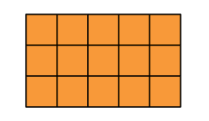  “On the grid, each square represents 1 square centimetre. There are 15 squares, so the area of the rectangle is 15 cm².” | Determines the area of regular shapes by counting whole and half squares.  “I counted squares on the 1-cm grid: 12 whole squares and 4 half squares, which make 2 whole squares, so the area is 14 cm.”
Observations/Documentation

Estimating and Investigating Area (cont’d)
Uses row and column structure of an array to determine area of a rectangle.  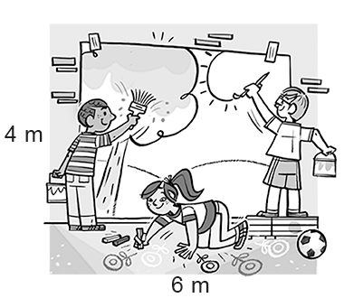  “I traced the shape on a grid and let each square represent 1 m². The rectangle forms an array with 4 rows of 6 squares: 4 × 6 = 24; the area of the mural is 24 m².” | Constructs different rectangles for a given area (square centimetres or square metres).  Area of rectangle = 16 cm²  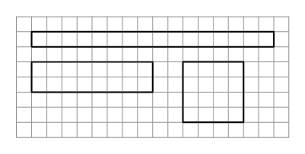  “I constructed 3 different rectangles: A square with side length 4 cm:  4 cm × 4 cm = 16 cm².  A 2-cm by 8-cm rectangle:  2 cm × 8 cm = 16 cm²  A 1-cm by 16- cm rectangle:  1 cm × 16 cm = 16 cm²” | Determines the area of irregular shapes by decomposing into known shapes.  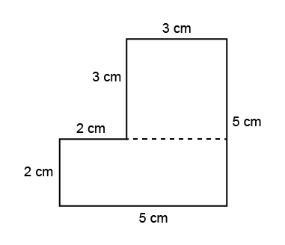  “I decomposed the shape into a square with side length 3 cm  and a rectangle with  length 5 cm and width 2 cm.  Area square:  A = 3 cm × 3 cm = 9 cm²  Area rectangle:  A = 5 cm × 2 cm = 10 cm²  Area of shape:  A = 9 cm² + 10 cm² = 19 cm²” | Flexibly determines the area of regular and irregular shapes and solves problems.  A driveway is made from 1 m2 tiles. It is a rectangle with area 75 m2. The driveway is 5 m wide. How long is it?  “I know A = l × w, so I solved the equation 75 = l × 5. I know 15 × 5 = 75, so the driveway is 15 m long.”
Observations/Documentation

