Investigating Perimeter
Uses standard units to measure the perimeter of irregular polygons by adding the lengths of its sides  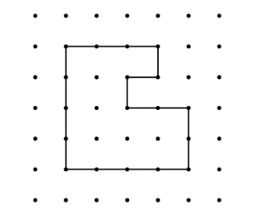  ”The polygon is on 1-cm dot paper. I added the lengths of the sides: 3 cm + 4 cm + 4 cm + 2 cm + 2 cm + 1 cm + 1 cm + 1 cm = 18 cm;  The perimeter of the shape is 18 cm.” | Uses standard units to calculate the perimeter of regular polygons.  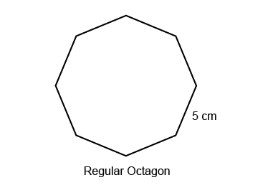  “In a regular octagon, all sides are the same length. To find the perimeter, I multiply the length of one side by the number of sides: 5 cm × 8= 40 cm. The perimeter is 40 cm.” | Constructs different polygons for a given perimeter.  Perimeter = 12 cm  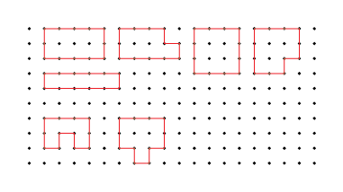  “I created these irregular and regular polygons, each with perimeter 12 cm. With irregular polygons, I added all the side lengths to check. The square is a regular polygon, so I multiplied the length of one side by 4.”
Observations/Documentation

Investigating Perimeter (cont’d)
Chooses an appropriate metric unit to estimate and measure perimeter of objects and explains reasoning.  “I used metres to measure the perimeter of the carpet because the carpet is longer and wider than the width of a door.  Length: 3 m, Width: 2.5 m.  Perimeter: 3 m + 2.5 m + 3 m + 2.5 m = 11 m.” | Understands the relationships among standard units of length and justifies when an exact measure of perimeter is needed.  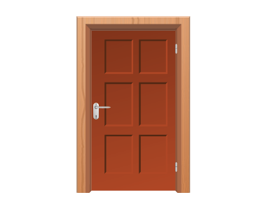  How much trim is needed to go around the door?  “An exact measure is needed so that the trim fits without gaps or overlaps.  I would use metres and centimetres.  Height: 2 m 54 cm,  Width: 1 m 6 cm  Perimeter: 2 m 54 cm + 2 m 54 cm + 1 m 6 cm + 1 m 6 cm = 6 m 120 cm, or 7 m 20 cm.” | Fluently solves problems in various contexts involving the perimeter of irregular and regular polygons.  Rashad wants to build a fence to make a rectangular pen for the rabbits using 24 m of fencing, in 1-m lengths. Which dimensions would you choose for the pen?  “The sum of a length and a width is  one-half of 24 m, or 12 m.  The possible dimensions are: 1 m by 11 m;  2 m by 10 m; 3 m by 9 cm; 4 m and 8 m;  5 m by 7 m; 6 m by 6 m.  I would choose 6 m by 6 m to make a square pen that would fit in my backyard.”
Observations/Documentation

