Locating and Plotting Points in First Quadrant of Cartesian Plane
Uses coordinates to describe the location of points on a grid.  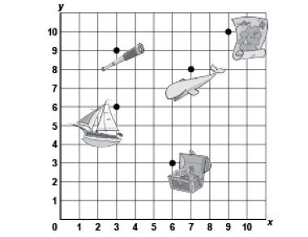  “The treasure chest is located at  (6, 3).” | Plots, locates, and labels points on a grid to make 2-D shapes.  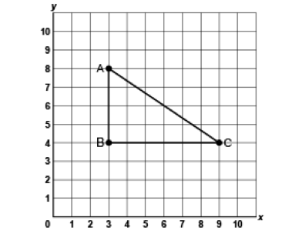  “I plotted A(3,8), B(3,4) and C(9,4) to create a right triangle.” | Translates a point and identifies coordinates of its image.  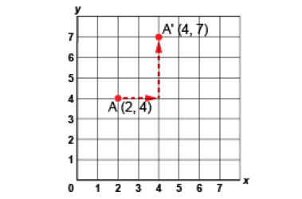  “I moved Point A right 2 squares, then up 3 squares.  The image of Point A after the translation is A’(4, 7).” | Flexibly predicts the location and coordinates of a point after a translation.  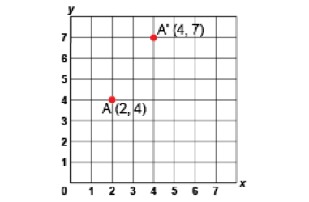  “The translation was right 2 squares and up 3 squares. So, I added 2 to the x-coordinate and 3 to the  y-coordinate:  (2 + 2, 4 + 3) A’(4, 7).”
Observations/Documentation

Exploring 2-D Shapes by Applying and Visualizing Reflections
Recognizes a reflection on a grid and identifies the line of reflection.  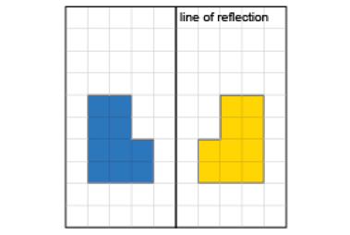  “The shape and its image are congruent and they are mirror images of each other.” | Counts squares to show that matching vertices are the same distance from line of reflection.  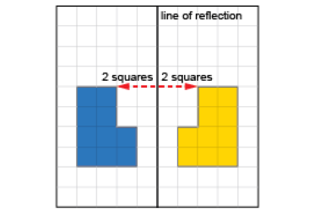  “These matching vertices are both 2 squares from the line of reflection.” | Performs reflections using labelled vertices over various lines of reflection.  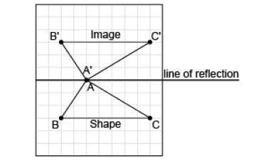  “I labelled matching vertices with the same letter. The vertices of the image have prime symbols.” | Visualizes, predicts, and describes where the image of a shape will be after a reflection.  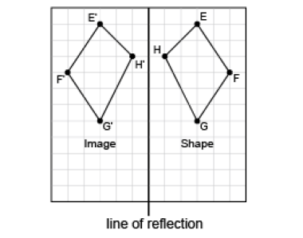  “I can picture the image on the other side of the line, so that matching vertices are the same distance from the line of reflection.”
Observations/Documentation

