Exploring 2-D Shapes by Applying and Visualizing Reflections
Recognizes a reflection on a grid and identifies the line of reflection.  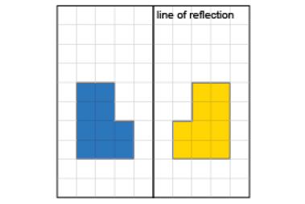  “The shape and its image are congruent and they are mirror images of each other.” | Counts squares to show that matching vertices are the same distance from line of reflection.  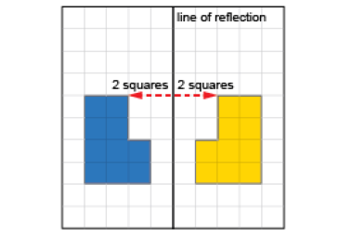  “These matching vertices are both 2 squares from the line of reflection.” | Performs reflections using labelled vertices over various lines of reflection.  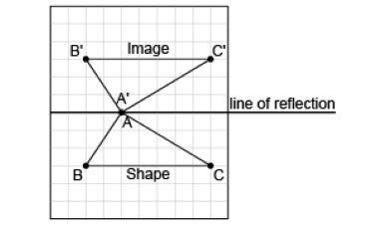  “I labelled matching vertices with the same letter. The vertices of the image have prime symbols.” | Visualizes, predicts, and describes where the image of a shape will be after a reflection.  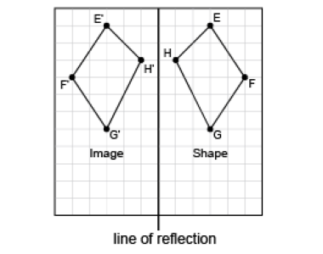  “I can picture the image on the other side of the line, so that matching vertices are the same distance from the line of reflection.”
Observations/Documentation

