Locating and Plotting Points in First Quadrant of Cartesian Plane
Uses coordinates to describe the location of points on a grid.  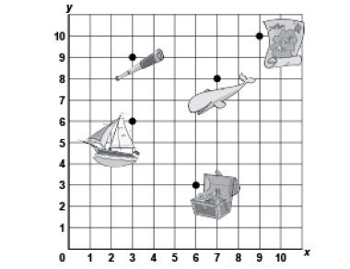  “The treasure chest is located at  (6, 3).” | Plots, locates, and labels points on a grid to make 2-D shapes.  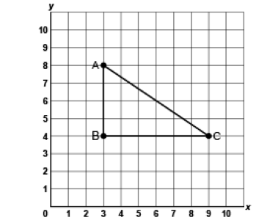  “I plotted A(3,8), B(3,4) and C(9,4) to create a right triangle.” | Translates a point and identifies coordinates of its image.  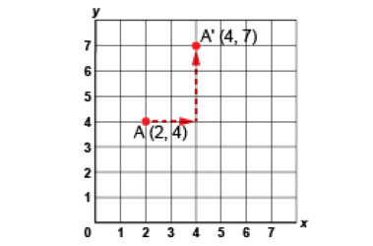  “I moved Point A right 2 squares, then up 3 squares.  The image of Point A after the translation is A’(4, 7).” | Flexibly predicts the location and coordinates of a point after a translation.  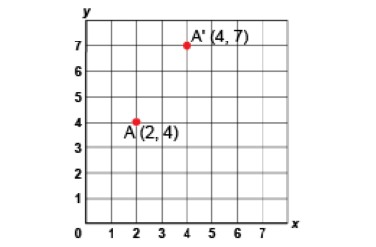  “The translation was right 2 squares and up 3 squares. So, I added 2 to the x-coordinate and 3 to the  y-coordinate:  (2 + 2, 4 + 3) A’(4, 7).”
Observations/Documentation

