Identifying and Classifying Angles
Identifies and classifies angles as right, obtuse, acute or straight.  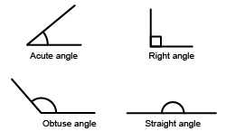  “I know that a right angle has perpendicular lines that make a 90° angle.” | Identifies and classifies angles within shapes.  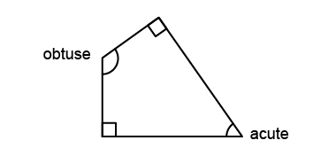  “This shape has 2 right angles, 1 obtuse angle, and 1 acute angle.” | Identifies and classifies angles in the real world.  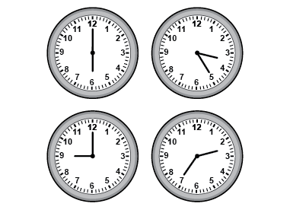  “Clocks can show different types of angles and can be used as benchmarks to classify objects.” | Flexibly locates, identifies, and classifies angles in the real world.  “I can find all 4 types of angles in this window and doorway.”  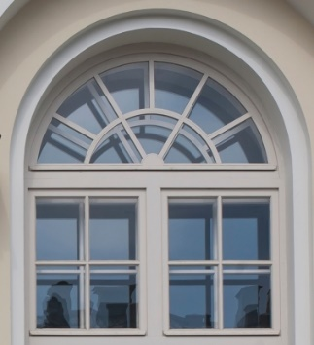
Observations/Documentation

Sorting Polygons
Recognizes a polygon as a closed shape with straight lines.  “I know these are polygons because they are closed shapes with straight sides.” | Understands that regular polygons have equal sides and equal angles.  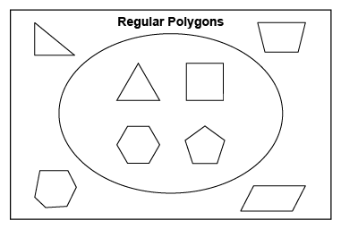  “The shapes inside the loop are regular polygons because they have equal sides and equal angles.” | Describes differences and similarities between regular and irregular polygons.  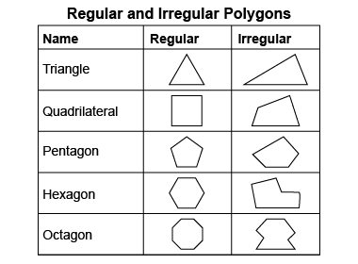  “The polygons in the second row are both quadrilaterals because they both have 4 sides. The square is a regular polygon because it has 4 equal sides and 4 equal angles, but the other quadrilateral is irregular because it does not  have any equal sides.” | Flexibly identifies and classifies polygons.  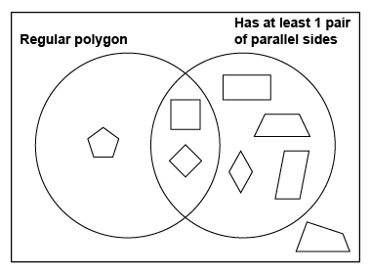  “I sorted the polygons using the Venn diagram. The irregular quadrilateral is outside of the loops because it has neither attribute.”
Observations/Documentation

