Identifying and Classifying Angles
Recognizes a rectangle by the number of sides and right angles.  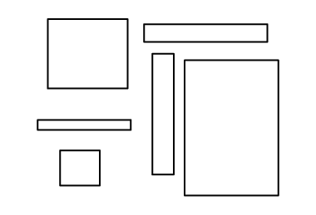  “I know that these are rectangles because they have 4 sides and 4 right angles.” | Understands that rectangles have opposite sides that are parallel and equal.  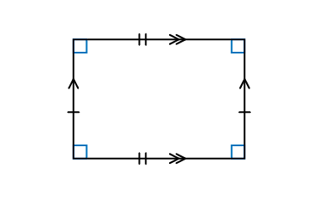  “A rectangle must have opposite sides that are parallel and equal in length.” | Understands that a rectangle has 2 lines of symmetry.  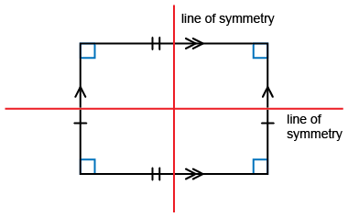  “Every rectangle will have 2 lines of symmetry. You could check by folding the shape or by  using a Mira.” | Uses properties to sort quadrilaterals into rectangles and non-rectangles.  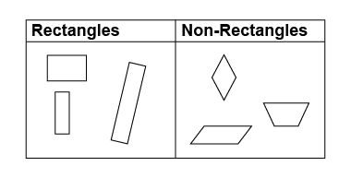  “All rectangles must have 4 sides,  4 right angles, opposite sides equal and parallel, and 2 lines of symmetry. A trapezoid isn’t a rectangle because opposite sides are not always the same length.”
Observations/Documentation

