Identifying and Classifying Angles
Identifies and classifies angles as right, obtuse, acute or straight.  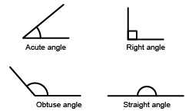  “I know that a right angle has perpendicular lines that make a 90° angle.” | Identifies and classifies angles within shapes.  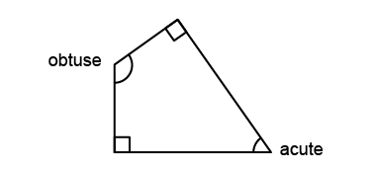  “This shape has 2 right angles, 1 obtuse angle, and 1 acute angle.” | Identifies and classifies angles in the real world.  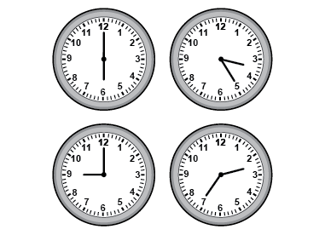  “Clocks can show different types of angles and can be used as benchmarks to classify objects.” | Flexibly locates, identifies, and classifies angles in the real world.  “I can find all 4 types of angles in this window and doorway.”  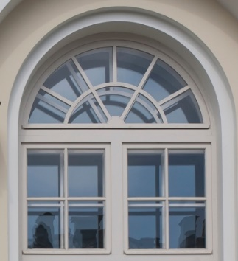
Observations/Documentation

