Describing and Constructing Regular and Triangular Prisms
Recognizes and names common attributes of rectangular and triangular prisms.  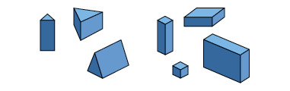  “Triangular prisms have some faces that are triangles. Rectangular prisms have faces that are rectangles.” | Describes attributes of rectangular and triangular prisms.  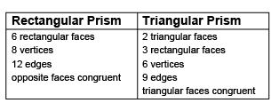 | Sorts a set of rectangular and triangular prisms using the shape of the base.  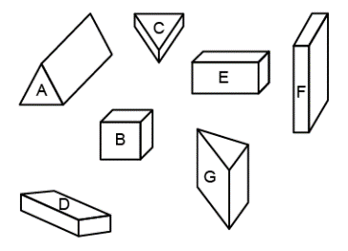  “When the shape of the base is a triangle, it’s a triangular prism.”
Observations/Documentation

Describing and Constructing Regular and Triangular Prisms (cont’d)
Constructs and describes models of rectangular and triangular prisms using various materials.  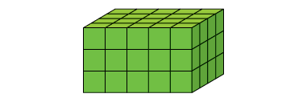  “I made a rectangular prism using linking cubes. All the faces are rectangles and there are 8 vertices.” | Constructs rectangular and triangular prisms from their nets.  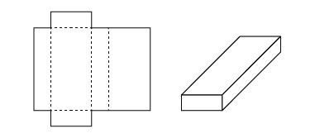  “I knew this would make a rectangular prism because there are 3 pairs of congruent rectangles and when I visualized folding the net, they were opposite each other.” | Makes and applies generalizations about rectangular and triangular prisms to objects in the environment.  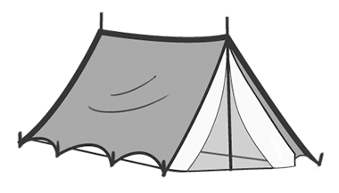  “A tent shaped like a triangular prism only needs one pole in the centre to support it and there is easy access through the triangular-faced door. The rectangular faces make it sturdy.”
Observations/Documentation

Understanding Line Symmetry
Identifies a line of symmetry on 2-D shapes using various tools.  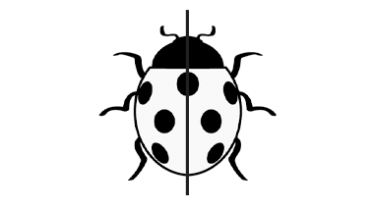  “I used a Mira to find the line of symmetry. When I folded the ladybug in half along the line, the two halves matched exactly.” | Identifies more than one line of symmetry on 2-D shapes.  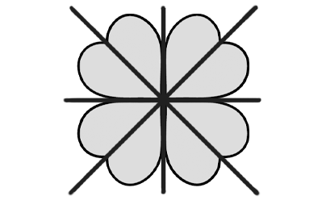  “The clover has 4 lines of symmetry. I could prove it by folding, using a Mira, or cutting and laying parts on top of each other.” | Sorts shapes according to the number of lines of symmetry; none, one, or more than one.  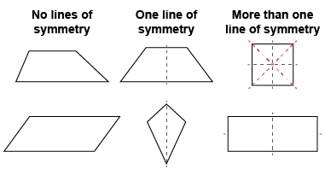  “Some shapes don’t have a line of symmetry and are not symmetrical. Other shapes have more than one line of symmetry.” | Recognizes symmetry in the environment and makes connection to congruence.  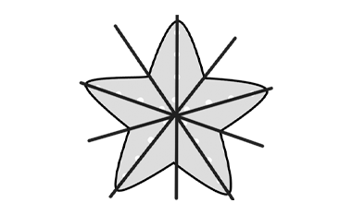  “A starfish has 5 lines of symmetry and for each line, the two halves are congruent.”
Observations/Documentation

