Understanding Line Symmetry
Identifies a line of symmetry on 2-D shapes using various tools.  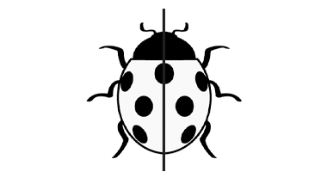  “I used a Mira to find the line of symmetry. When I folded the ladybug in half along the line, the two halves matched exactly.” | Identifies more than one line of symmetry on 2-D shapes.  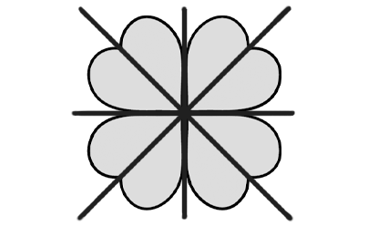  “The clover has 4 lines of symmetry. I could prove it by folding, using a Mira, or cutting and laying parts on top of each other.” | Sorts shapes according to the number of lines of symmetry; none, one, or more than one.  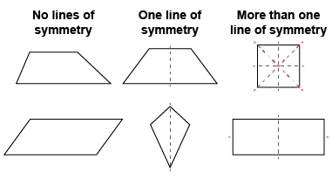  “Some shapes don’t have a line of symmetry and are not symmetrical. Other shapes have more than one line of symmetry.” | Recognizes symmetry in the environment and makes connection to congruence.  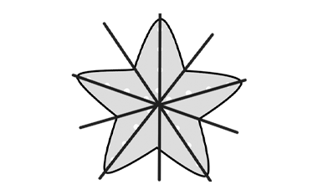  “A starfish has 5 lines of symmetry and for each line, the two halves are congruent.”
Observations/Documentation

