Predicting Likelihoods Involving Mean, Median, and Mode
Identifies mode, median, and mean of a data set.  Minutes to get to school for 10 Grade 4 students:  5, 10, 30, 20, 25, 10, 10, 2, 3, 5  “Mode: 10 min; Median: 10 min, Mean: 12 min.” | Predict likelihood of mean, median and mode being the same for another data set.  “I think they will be the same because the students are in the same grade.” | Collects data for a second population, then compares results with predictions.  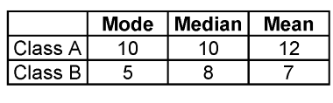  “The results are not what I predicted. I thought the mode, median, and mean would be the same for both classes.” | Understands that measures of central tendency from a different population may be different.  “A lot of students in my class live in a building that is close to the school. So, it takes them less time to get to school than the students  in the other class.”
Observations/Documentation

