Describing and Predicting Likelihood of Outcomes
Describes the likelihood of an outcome using language of probability (e.g., impossible, likely, equally likely).  “Landing on red and landing on blue  are equally likely.” | Makes comparisons to order the likelihoods of outcomes (on a probability line).  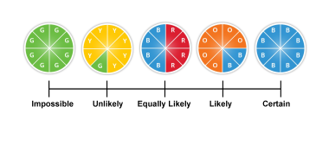 | Identifies the likelihood of an outcome for an experiment using words, fractions, or decimals.  “The likelihood of landing on blue is 2 out of 8,  or $\frac{2}{8}$ , or 0.25.”
Observations/Documentation

Describing and Predicting Likelihood of Outcomes (cont’d)
Makes predictions based on likelihoods.  “The likelihood of landing on blue is 2 out of 8, so in 40 trials, I think it will land on blue 10 times.” | Conducts experiments to check predictions about likelihood of outcomes.  “I performed the experiment and the pointer landed on orange 23 times and on blue 17 times. That’s not what I predicted. I thought I would get orange 30 times.” | Conducts experiments and realizes that as more trials are conducted, the closer the results will likely be to the predictions.  “I performed the experiment 100 times and the results were much closer to my predictions.”
Observations/Documentation

