Multiplication Squares Instructions
Master 18

Group size: 2
Materials:
• Student Card 17A: Multiplication Squares
• 2 number cubes, labelled 1−6
• 2 dry-erase markers (different colours)

Instructions:
Take turns rolling the number cubes and drawing a matching array on the grid.
Write the product inside the array.
For example, if you roll a 2 and a 3, you can draw an array of
2 rows of 3 squares, or 3 rows of 2 squares.
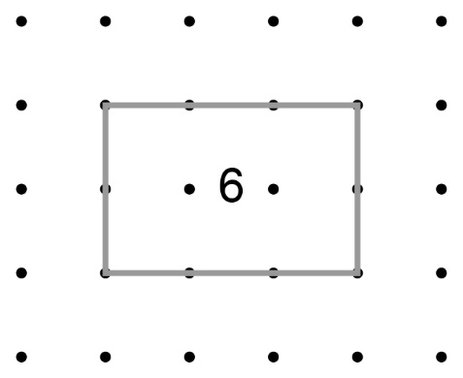

Continue to take turns until one of you runs out of room and cannot draw an array.
The other player wins.

Note: Arrays cannot overlap.

