Pawty Planning
Master 14

It’s time to plan a Birthday Pawty for 10 adorable dogs.
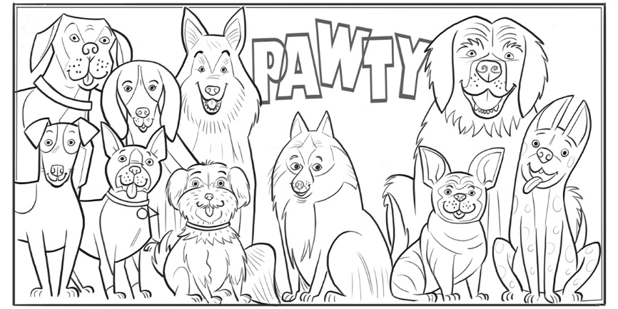

To play party games, divide dogs into equal teams.
Games
Tug of War: Teams of 2
Go Fetch: Teams of 3
Obstacle Course: Teams of 5
Hide-and-Seek: Teams of 4

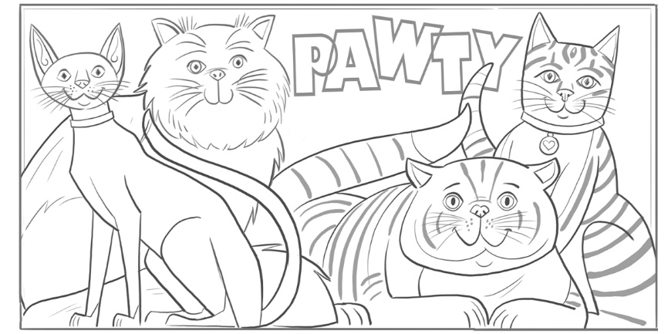
It’s time to plan a Birthday Pawty for 4 playful cats.

To make loot bags, share treats among 4 bags.

Treats
8 Toy Mice
20 Cat Treats
15 Toy Feathers
12 Dental Treats
5 Play Balls

