Connections: Art with Geometry
Master 72

This art of a fox was created by Isla, a young student artist.
She used lots of lines, angles, and shapes to create the drawing.
How would you describe this art to a friend?
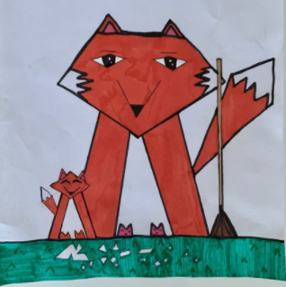

If you want to see more artwork by Isla, check out:
https://www.instagram.com/creations_by_isla.

Create your own piece of art that meets these criteria.
- has at least 3 different shapes
- has at least 4 of each type of angle (right angle, angle greater than a right angle, and angle less than a right angle)
You might choose to use Pattern Blocks create your art.

