**Nets of Solids**

**Master 56a**

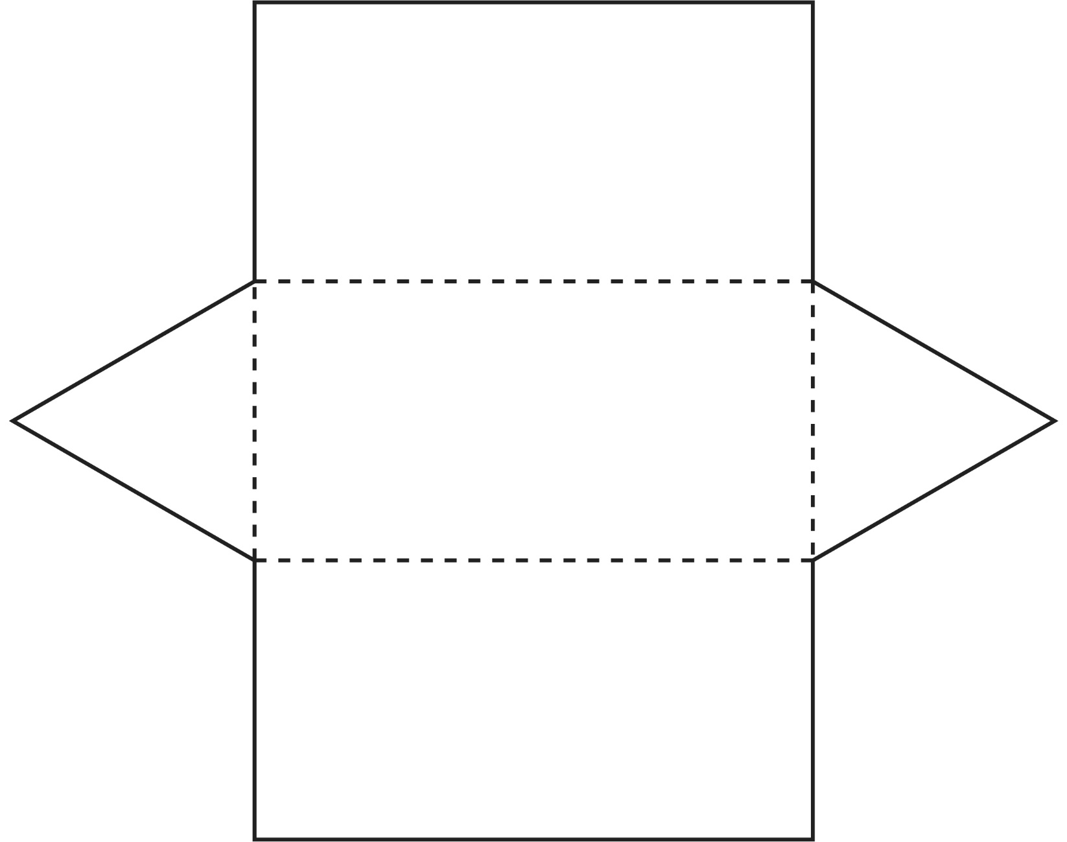

**Nets of Solids**

**Master 56b**

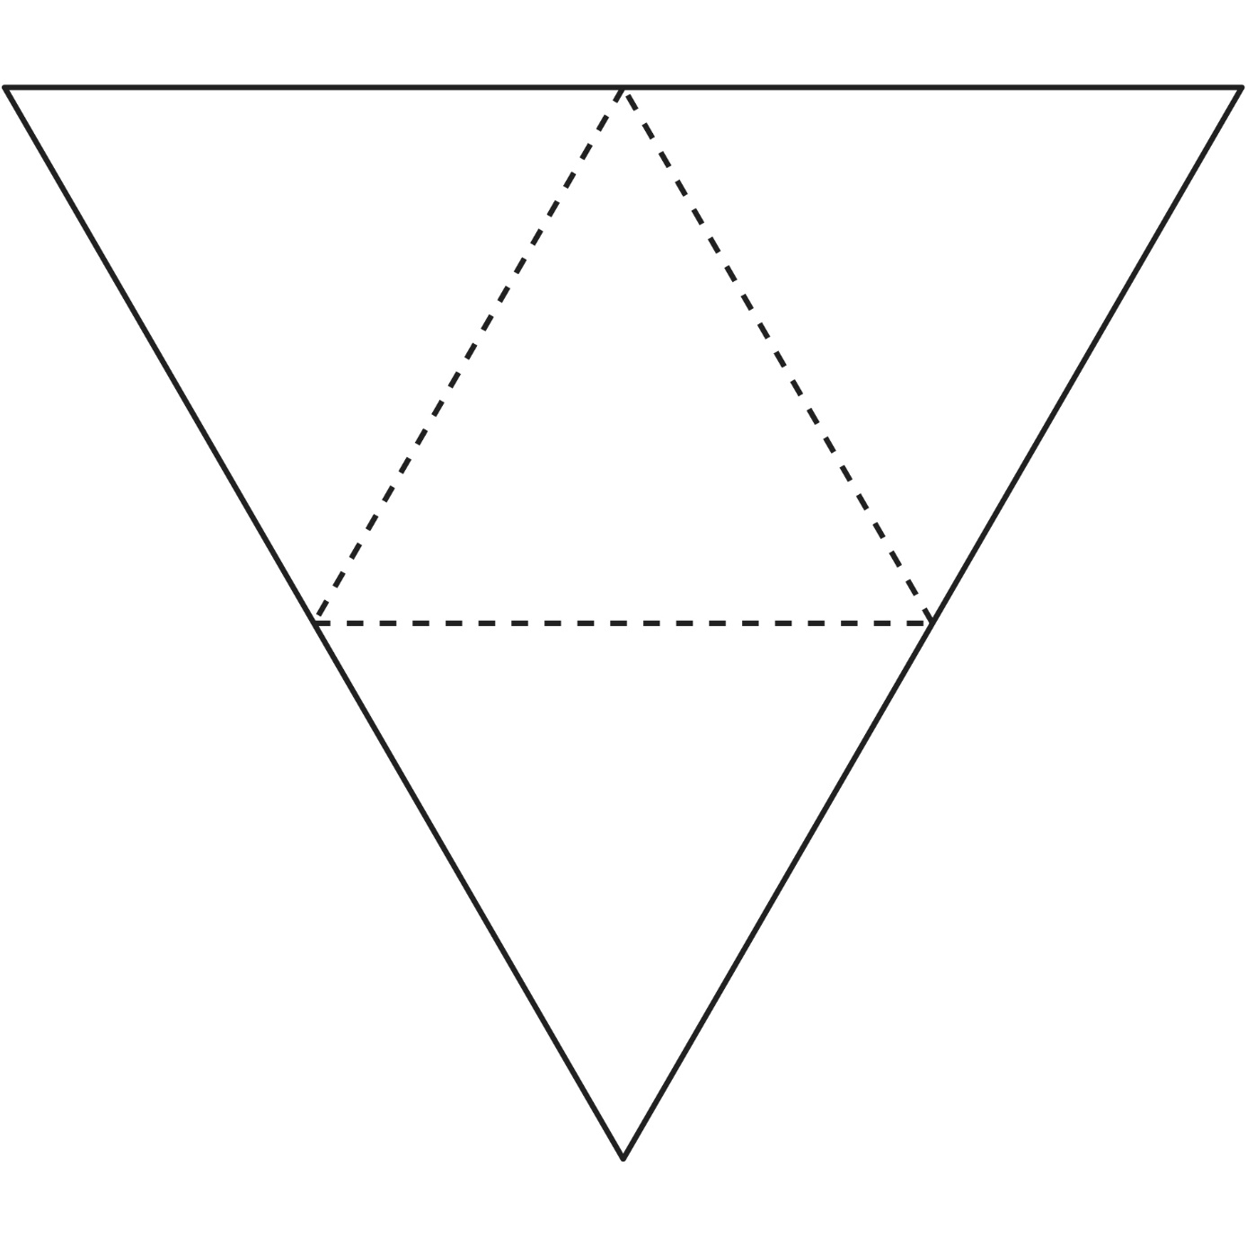

**Nets of Solids**

**Master 56c**

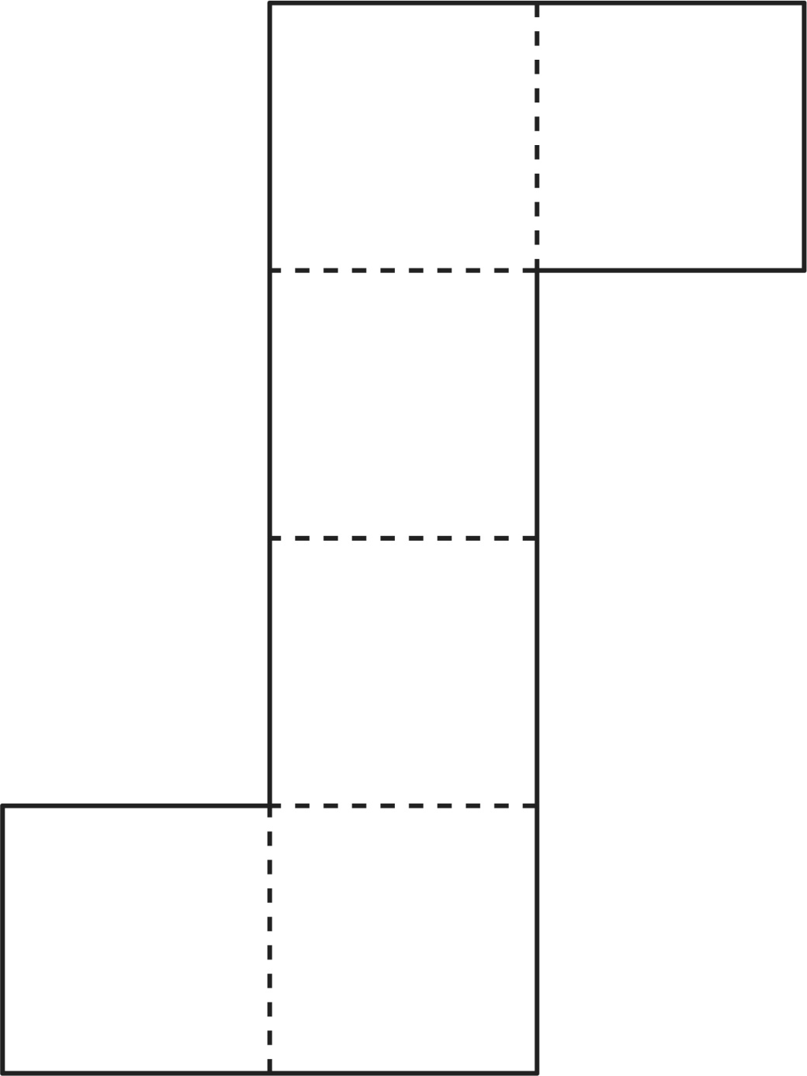

**Nets of Solids**

**Master 56d**

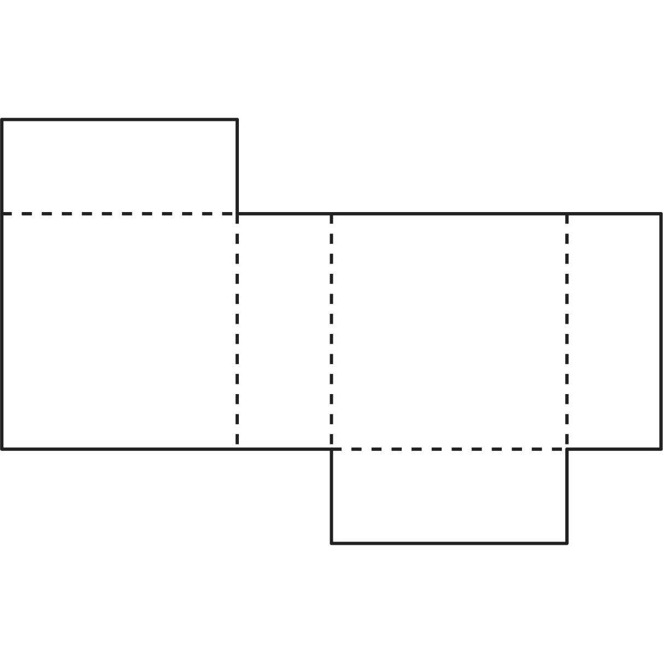

**Nets of Solids**

**Master 56e**

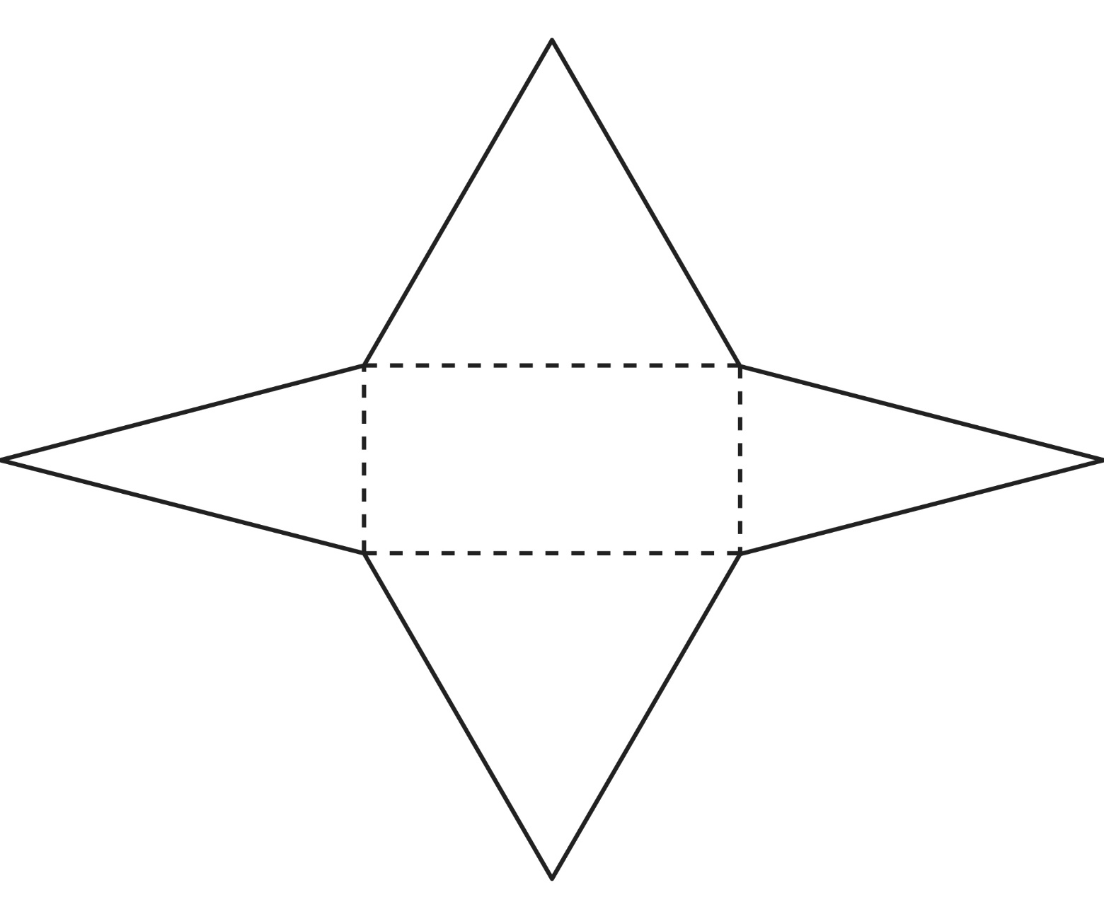

**Nets of Solids**

**Master 56f**

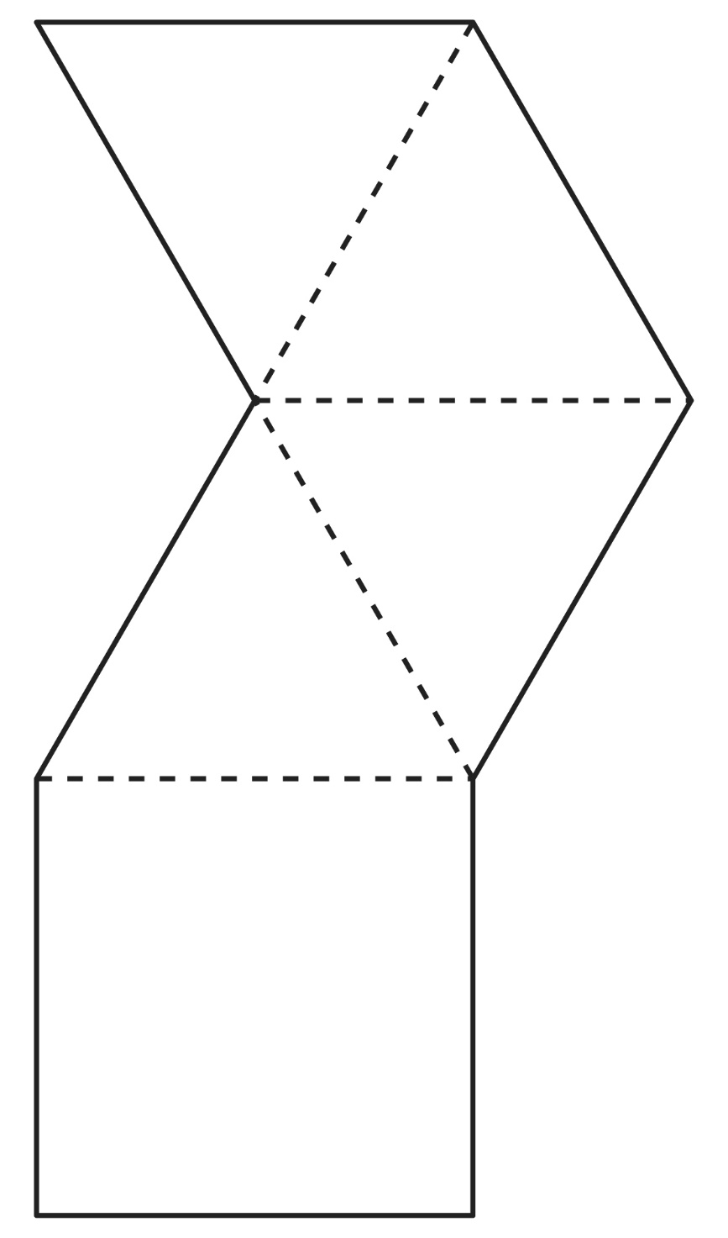

**Nets of Solids**

**Master 56g**

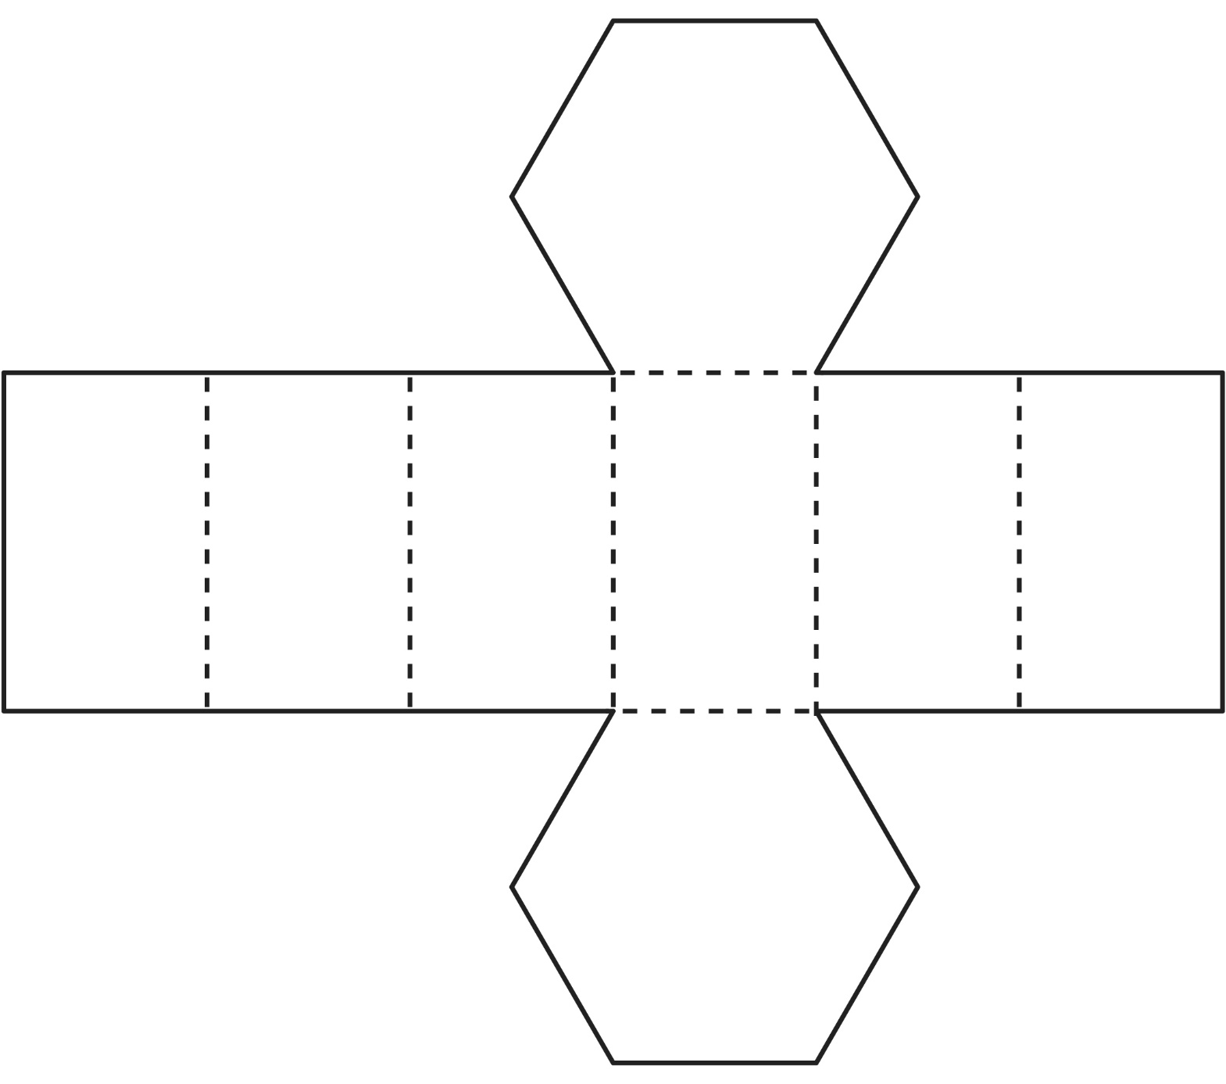

**Nets of Solids**

**Master 56h**

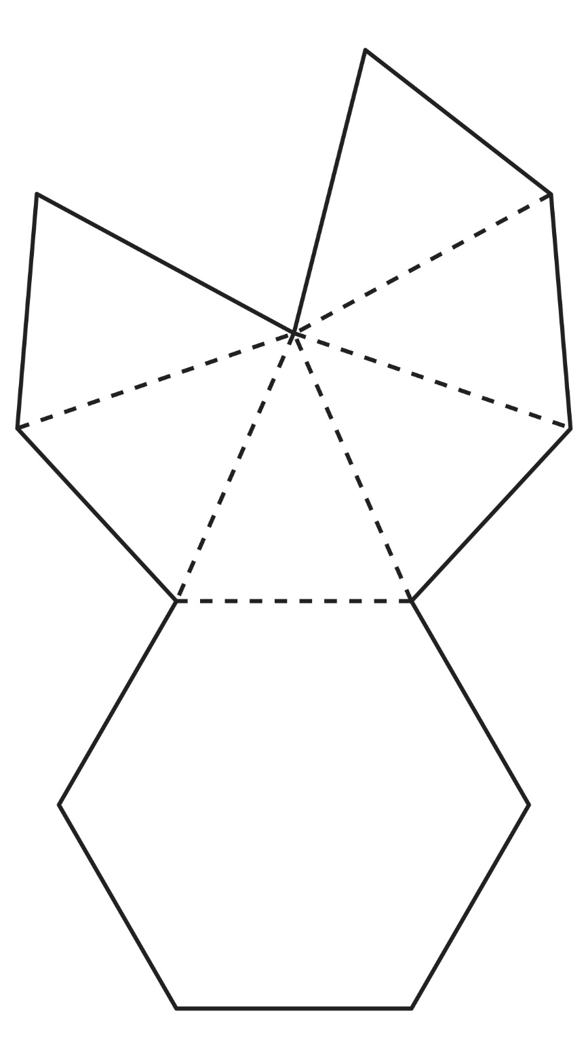

**Nets of Solids**

**Master 56i**

