**Types of Transportation**

**Master 77a**

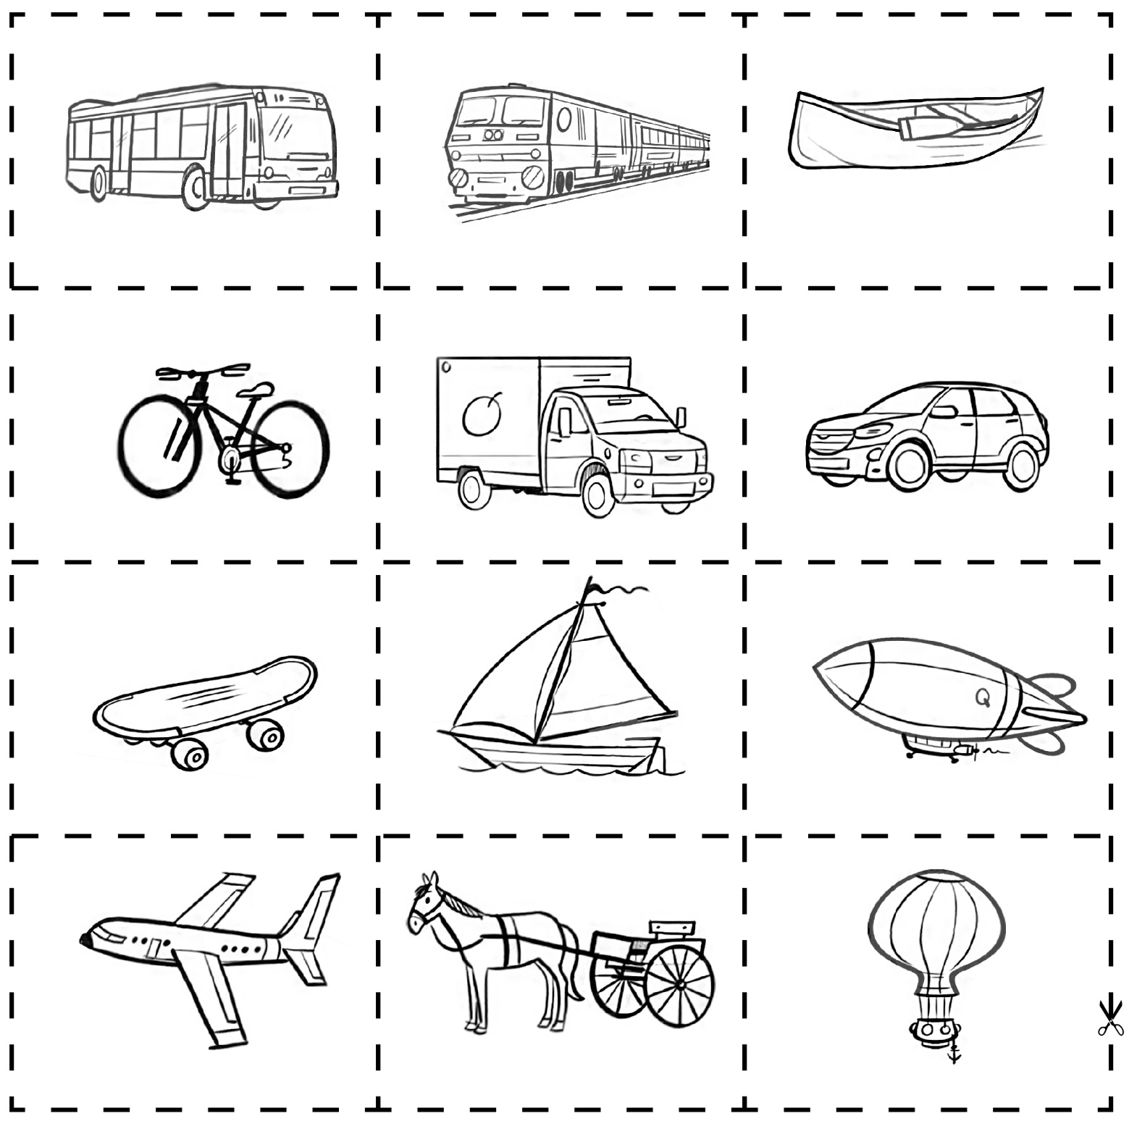

**Types of Transportation**

**Master 77b**

