Creating Repeating Patterns
Builds core with one attribute (e.g., always colour)  “red, blue, blue, yellow” | Builds core with one attribute (shape, size, colour)  “I changed shape.” | Creates patterns with one attribute in many ways (shape, size, colour)  “I copied the core two more times.”
Observations/Documentation
Builds core with two attributes  “I changed shape and colour.” | Creates patterns with two attributes  “I copied the core two more times.” | Represents the same pattern in many ways (e.g., letters, numbers, sounds)  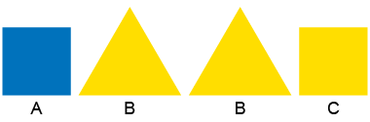  “I represented the pattern core with letters: ABBC.”
Observations/Documentation

