Comparing Money Amounts and Making Change
Compares money amounts using part-part-whole relationship  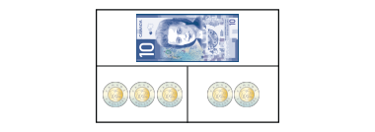  “The total cost is the whole. That’s $10. The cost of each item is a part. The items cost $6 and $4.” | Uses part-part-whole relationship to find a missing part  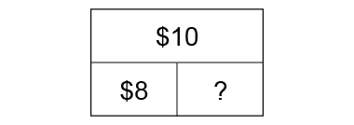  “Part + Part = whole so, 8 + ? = 10 or 10 – 8 = ? I model $10 with coins, then take away $8. I am left with $2, the missing part.” | Makes change using skip-counting  I had a $5 bill.  I bought:  Change:  “I skip-counted on from $3.50 by 25s, adding a quarter each time. 6 quarters is the same as $1.50.” | Uses different strategies to make change efficiently (e.g., counting on, counting back)  I had a $10 bill.  I bought:  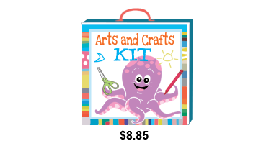  Change:  “I counted on from $8.85  and needed only 3 coins to  get to $10.”
Observations/Documentation

Understanding Equality with Money
Uses like coins to show equivalent amounts  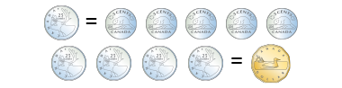  “I know 5 nickels make 1 quarter  and 4 quarters make $1.” | Uses different denominations of coins to show equivalent amounts  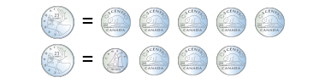  25 = 10 + 5 + 5 + 5  “I can show 25 cents with  5 nickels, then trade 2 nickels  for a dime.” | Determines total cost of purchase and shows equivalent amounts in different ways  $3.70 + $1.25 = $4.95  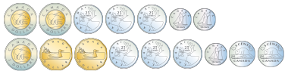  “I can pay $4.95 using lots of different coins, but I could also pay with a $5 bill, and get  5 cents change.” | Determines total value of purchase and shows equivalent amount in most efficient way  $6.25 + $5.45 + $4.50 = $16.20  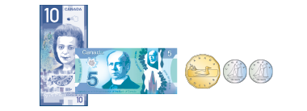  “I know that I can start with  $15 in bills, then add 1 dollar  and twenty cents.”
Observations/Documentation

