Decomposing and Composing Quantities
Randomly chooses a number as a part  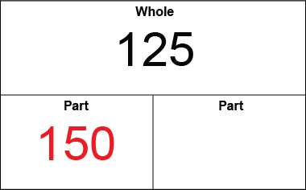  “I like the number 150.” | Finds one part of a whole  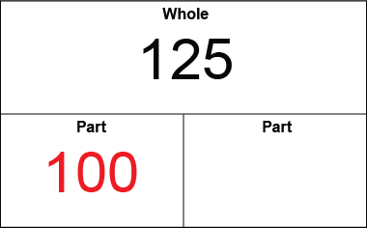  “I thought of a number less than 125: 100.” | Counts on or back to find the other part  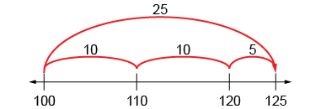  “I counted on: 100, 110, 120, 125;  the other part is 25.”
Observations/Documentation

Composes the whole in different ways using known pairs  100 and 25  50 and 75 | Uses patterns systematically to compose the whole, considering 0  “I kept taking 1 from a part and  giving it to the other.” | Uses number relationships and mental strategies to compose the whole  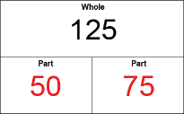  “75: I know 50 and 50 make 100, and 25 more makes 125.”
Observations/Documentation

Comparing and Ordering Quantities
Orders numbers randomly  125 245 179  “I just put down any card.” | Models with manipulatives  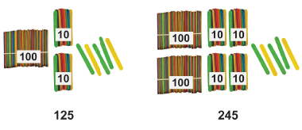 | Uses benchmark on hundred chart or number line  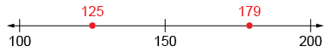  “I compared the numbers to 150.”
Observations/Documentation

Visualizes hundred chart or number line  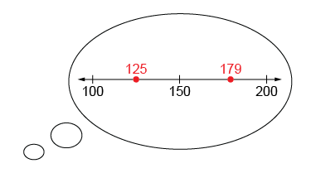  “I picture 179 farther to the right than 125.” | Compares numbers, digit by digit (with the same place value)  “Both start with 1, 2 is less than 7, and 5 is less than 9. So, 125 is less than 179.” | Orders three or more quantities (e.g., using early place-value, mental strategies)  179 245 326  “326 is greatest because 3 hundreds is more than both 2 hundreds and 1 hundred.”
Observations/Documentation

