Exploring Symmetry with 2-D Shapes
Identifies a line of symmetry in a design  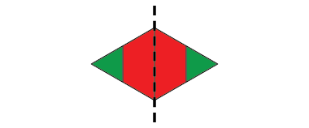  “I see one line of symmetry. If I fold the design on the line,  the 2 sides match exactly.” | Completes a symmetrical design, placing most shapes correctly  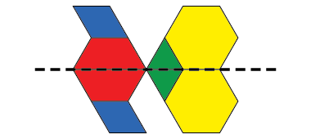  “I’m not sure about the blue block, but it looks right to me.” | Successfully completes a symmetrical design and uses math language to describe it  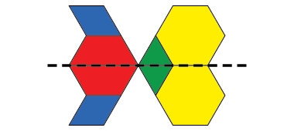  “This design is symmetrical because all the blocks below the line are reflections of the blocks above the line. I used a Mira to check.” | Constructs symmetrical designs and identifies all lines of symmetry  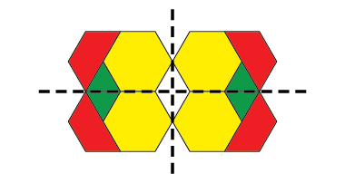  “I made my own design. It has  2 lines of symmetry.”
Observations/Documentation

Applying Transformations to 2-D Shapes
Identifies congruent shapes with same orientation  “These shapes are congruent because they have the same shape and size and are facing  the same way.” | Identifies congruent shapes with different orientations (uses physical movement)  “These shapes are congruent because  when I turn one shape,  it matches the other shape exactly.” | Identifies congruent shapes with different orientations (uses visualization)  “These shapes are congruent because  I can picture turning one shape  half a turn to match the other.”
Observations/Documentation

Applying Transformations to 2-D Shapes (con’t)
Identifies translations but struggles to differentiate between reflections and rotations  “I would translate A to the right to get B.  I’m not sure whether I would reflect or rotate C  to get D.” | Performs the transformation needed to match two congruent shapes (i.e., rotation, reflection, or translation)  “I used a Mira and the two shapes matched exactly. So, Shape C was reflected.” | Uses orientation to flexibly predict and describe transformation of congruent shapes  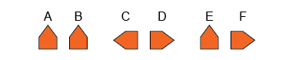  “From A to B: same orientation, so translation  to the right; from C to D: opposite orientations,  so a reflection in vertical line between C and D;  from E to F: different orientations,  so quarter-turn clockwise rotation.”
Observations/Documentation

