Investigating Geometric Attributes of 2-D Shapes
Recognizes and names familiar 2-D shapes  “The top of my desk has the shape  of a rectangle.” | Groups shapes that share the same geometric attributes  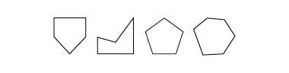  “The first three shapes all have 5 sides, so they are pentagons. The last shape doesn’t belong. It has 6 sides.” | Analyzes geometric attributes of 2-D shapes (e.g., number and length of sides, number of vertices)  "The first two are irregular pentagons as not all sides are equal. The third one is regular because all sides are equal.”
Observations/Documentation

Investigating Geometric Attributes of 2-D Shapes (con’t)
Uses attributes to compare and sort shapes  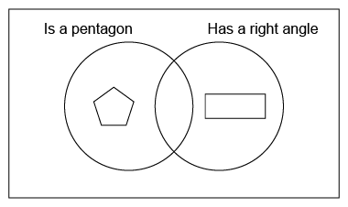  “I need a shape with 5 sides and at least  one right angle to go in the overlap.” | Uses attributes to name shapes in different ways  “A rectangle can also be called a parallelogram because it has 2 pairs of parallel sides.” | Sorts, classifies, and names shapes flexibly using geometric attributes  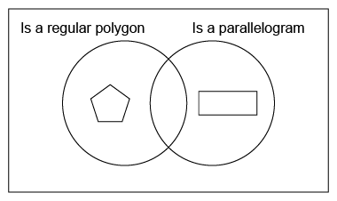  “The sorting rule could be ‘Is a regular polygon and is a parallelogram.’”
Observations/Documentation

Composing and Decomposing 2-D Shapes
Constructs composite shape using copies of the same Pattern Block  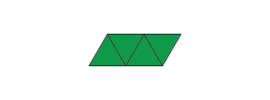  “I can use 4 triangles to make  a parallelogram.” | Constructs composite shape from Pattern Blocks in more than one way  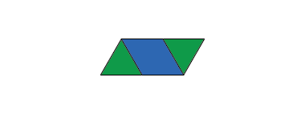  “I can also use 2 triangles and a rhombus to make a parallelogram.” | Completes a picture outline with Pattern Blocks  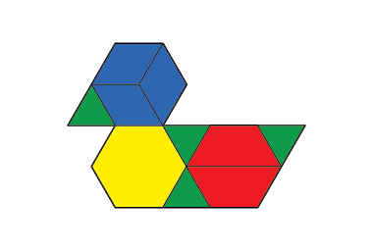  “I used 10 blocks to cover the outline. I tried to use a variety  of blocks.” | Constructs composite shapes in many ways by decomposing shapes and rearranging parts  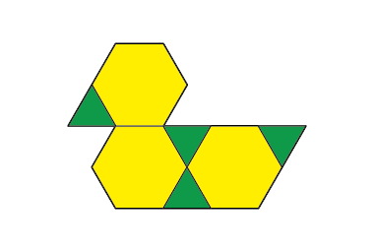  “I traded 3 blue blocks for a yellow block, and 2 red blocks for a yellow block. I was able to cover the outline using only 7 blocks. When I use only green blocks, it takes 22 blocks.”
Observations/Documentation

