Creating Graphical Displays
Creates graph but does not relate sample responses to labels  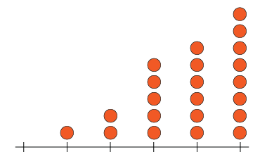 | Creates graph with labels but omits title or scale  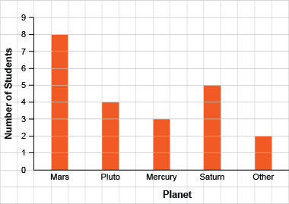 | Successfully creates graphs (always of same type)  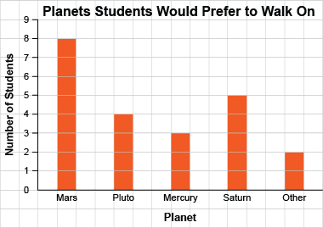 | Creates graphs flexibly; shows same data on different graph types  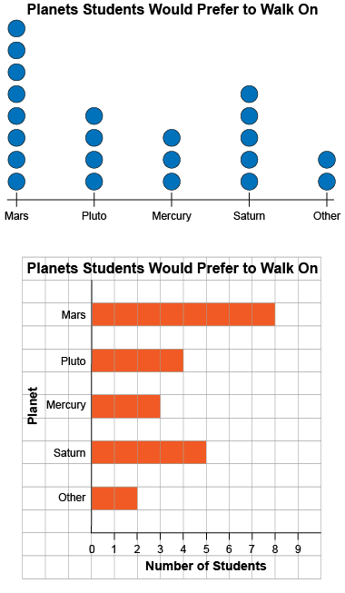
Observations/Documentation

Reading and Interpreting Data Displays
Notices the basic shape of graph | Counts symbols or squares to read data  “1, 2, 3, …, 10, 11, 12 squares are shaded. Henrietta laid 12 eggs.” | Uses scale to read data  “The bar has height 12. Henrietta laid  12 eggs.”  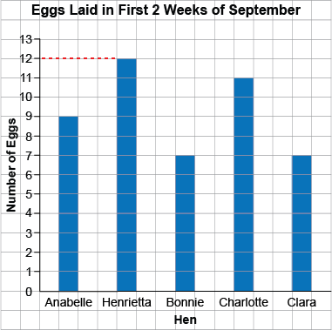
Observations/Documentation

Reading and Interpreting Data Displays (con’t)
Makes direct comparisons between data  “1 squirrel was seen 3 more times than  0 squirrels.”  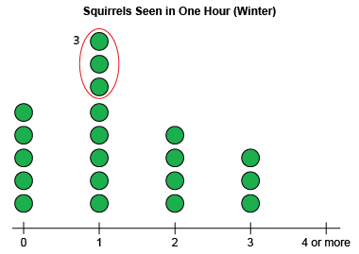 | Uses data to answer some questions  “5 + 8 + 4 + 3 = 20; 20 students were surveyed.”  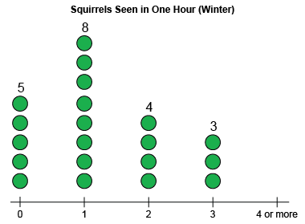 | Draws conclusions from data  “Most students saw 1 squirrel in one hour in the winter.”  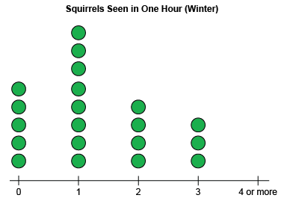
Observations/Documentation

