Connections: Patterns in Nature
Master 30

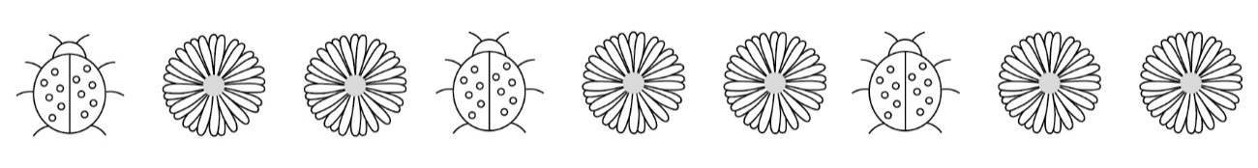
We often think of a pattern as something that repeats again and
again in the same way.

In nature, patterns can be found everywhere, including on animals, plants, and in the sky.

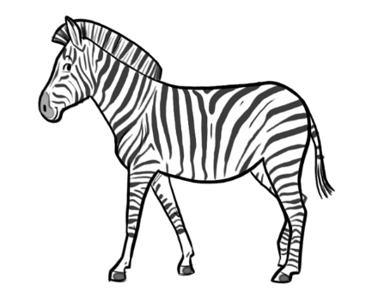
A zebra’s stripes form a pattern, although no two stripes are
exactly the same.

Zebra

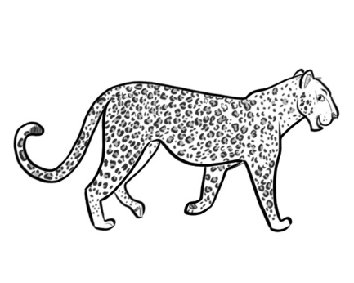
What patterns do you see?
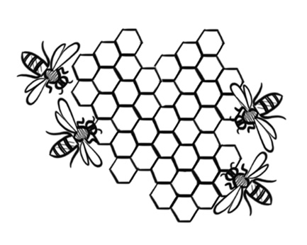
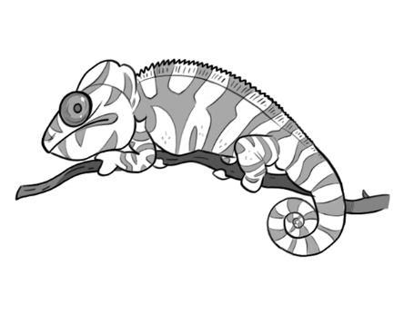

Honeycomb
Chameleon
Leopard

Look around you. What patterns do you see?

