Connections: Vyshyvanka
Master 29

Vyshyvanka is the Ukranian name for embroidered shirt.

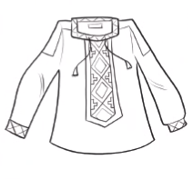

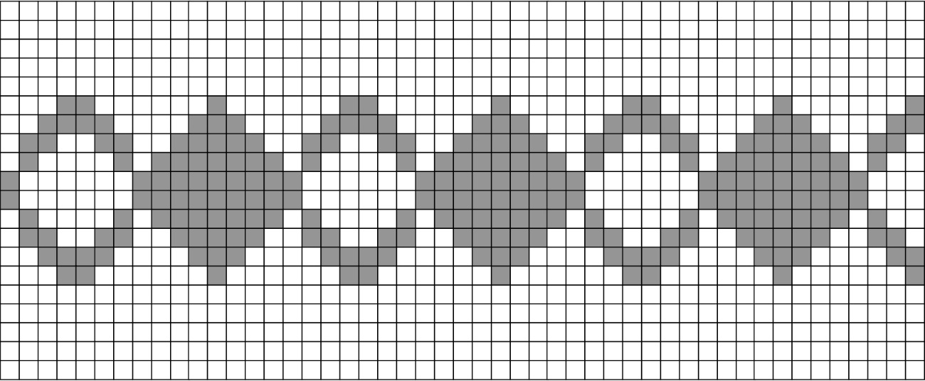
Ukrainian embroidery often contains hidden meanings.
When people embroider shirts or blouses for others, they include
symbols that are meant to protect them or bring good luck.
What increasing or decreasing pattern do you see in the stitches?

mtr3_p1_l07_12_blm_art

Copy the pattern on a grid.
What is the pattern rule?

Do some research to learn about the meaning of different symbols in this type of embroidery.

