Multiplication Triangles Instructions
Master 20

Group size: 2
Materials:
• Master 16: Multiplication Triangles Game Board
• 2 number cubes, labelled 1−6
• 2 markers (different colours)

Goal: To make more triangles

Instructions:
Take turns to roll the number cubes and multiply the numbers.
Look for the answer on the board.
Connect any two dots to form a side of the triangle.
When you draw a line that closes a triangle, colour the triangle with your marker. Take another turn.
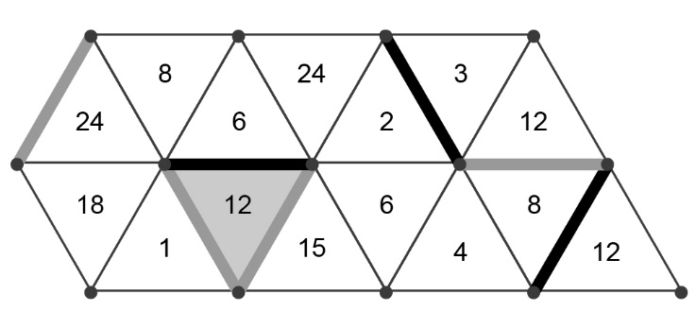

When all dots have been connected, the player with more triangles coloured wins.

