**Is It a Net?**

**Master 49a**

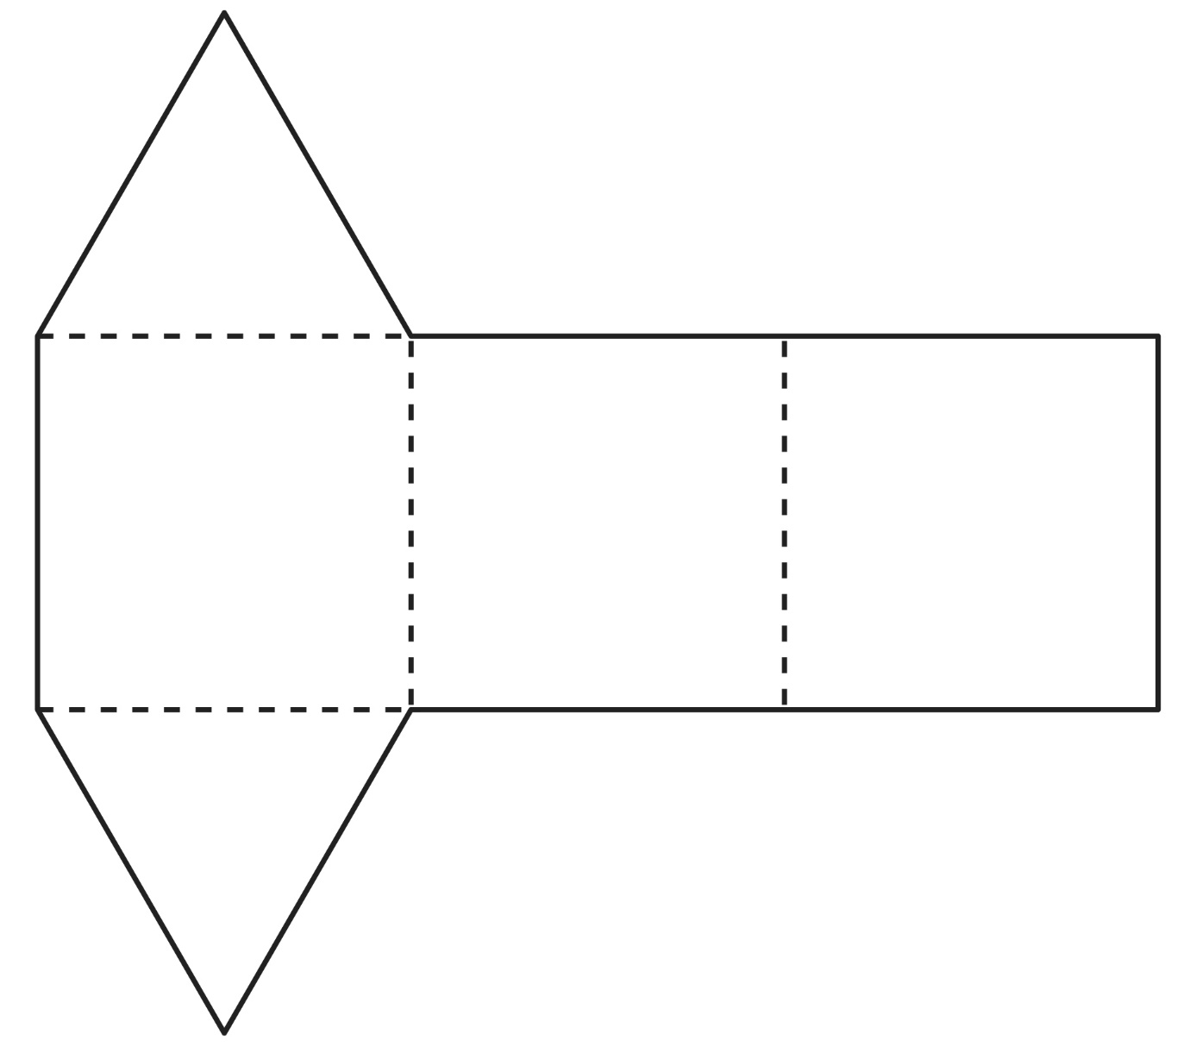

**Is It a Net?**

**Master 49b**

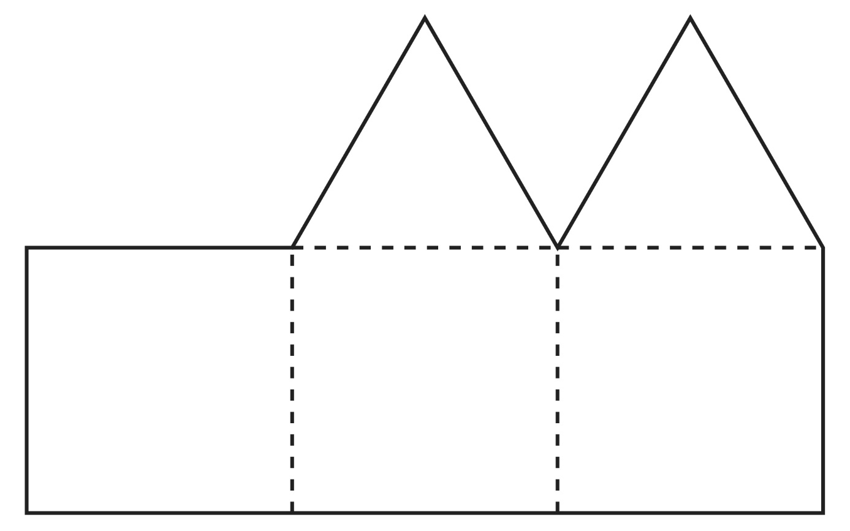

**Is It a Net?**

**Master 49c**

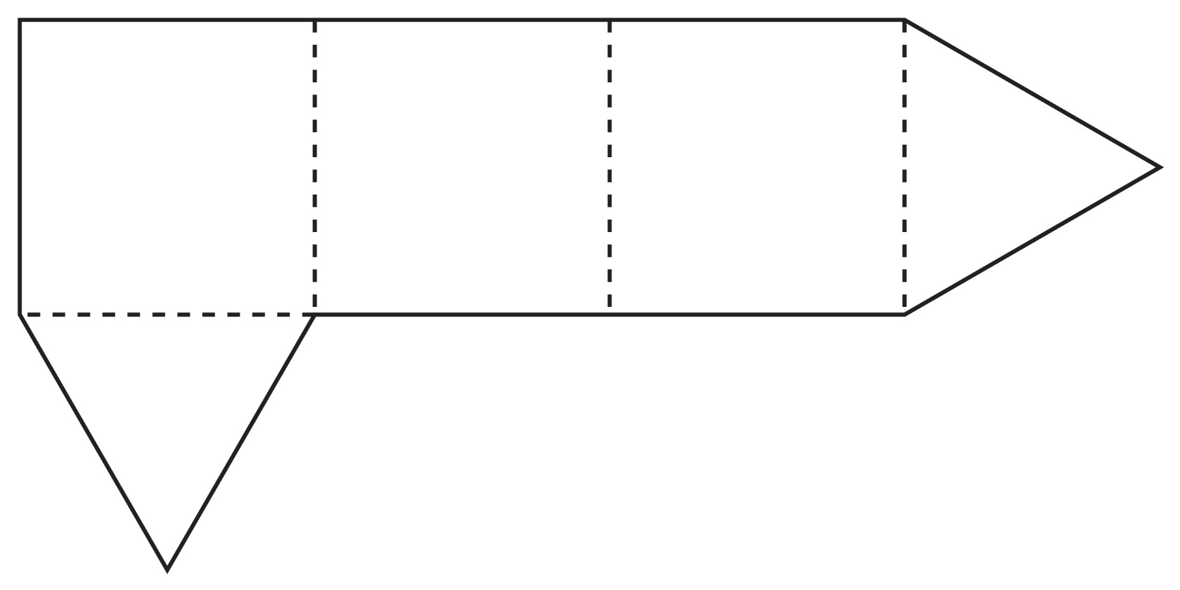

**Is It a Net?**

**Master 49d**

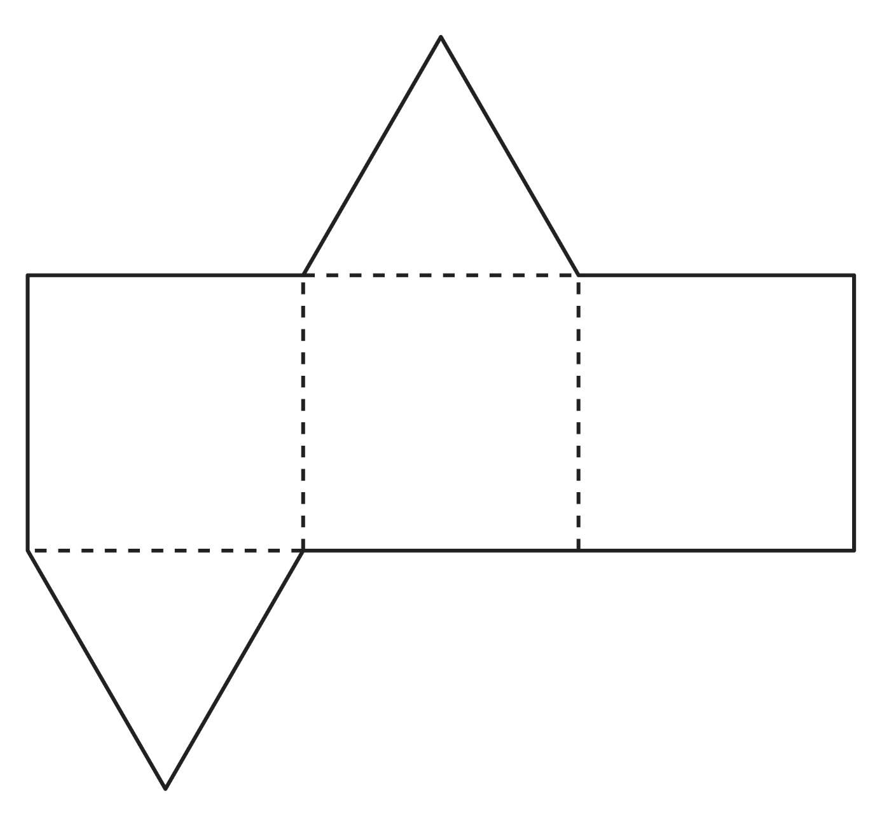

**Is It a Net?**

**Master 49e**

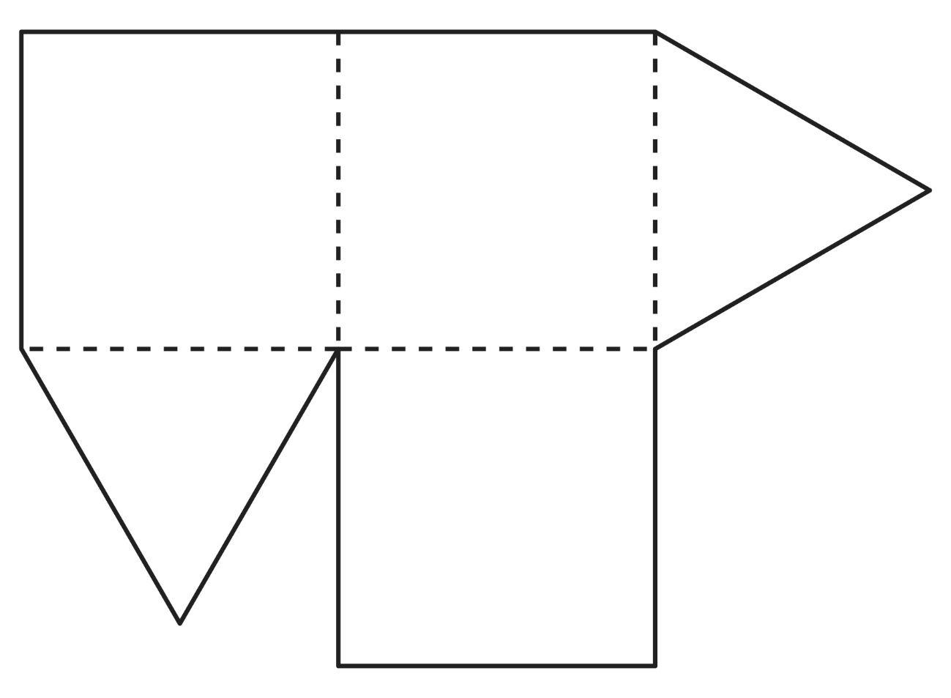

**Is It a Net?**

**Master 49f**

