Connections: Teatime
Master 51

Tea comes in many interesting flavours.
Have you ever heard of Gummy Bear Tea or Vanilla Berry
Cupcake Tea?

Tea leaves can be packaged in tea bags.
Hot water goes through the tiny holes in the bags,
causing the tea leaves to expand and release their flavour.

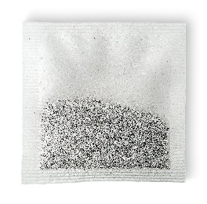
The bags may look like triangular pyramids or be circular
or square.
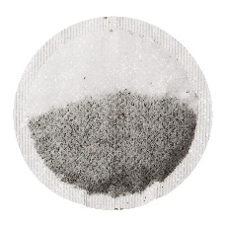
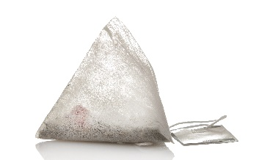

Tea leaves can also be used loose.
For example, they can be put in a glass teapot
with a tea infuser shaped like a cylinder.

Create your own flavour of tea.
How would you package it?
Describe the 2-D shape or 3-D solid you would use.
What are the advantages and disadvantages of the “package shape”
you chose?
Checklist
• environmentally friendly
• room for tea leaves to expand
• material allows water to enter easily
• fits in a cup or mug

