Connections:
What’s the Chance?

Master 71

Chance is the likelihood that something will happen.
Chance is all around us.
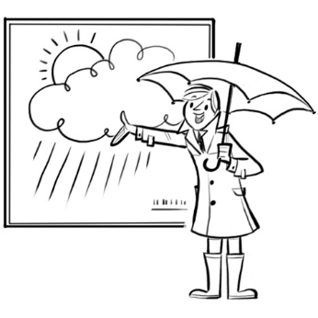  We hear chance when we listen to the weather forecast.  “It is very likely to rain tomorrow.” | 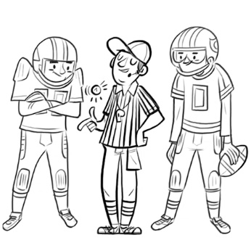  We see chance when watching a  football game.  A coin is tossed to see who gets the  ball first.
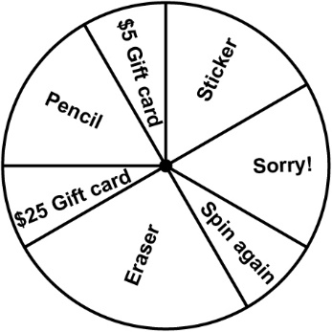  Have you ever spun to win a prize?  What is the chance of winning a  good prize?  Why do you think this is? | 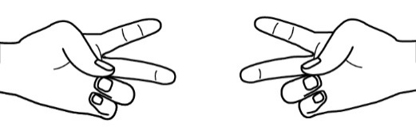  Think about games you play.  What is the chance of both players  showing scissors when playing  Rock, Paper, Scissors?
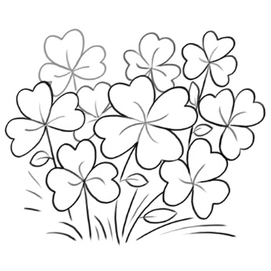  What is the chance of finding a  four-leaf clover? | 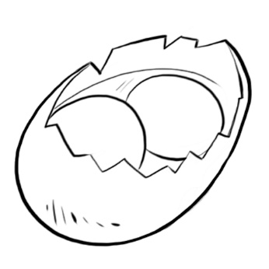  What is the chance of getting an egg with two yolks?

