Comparing Money Amounts and Making Change
Compares money amounts using part-part-whole relationship  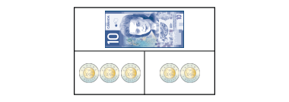  “The total cost is the whole. That’s $10. The cost of each item is a part. The items cost $6 and $4.” | Uses part-part-whole relationship to find a missing part  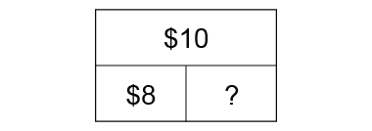  “Part + Part = whole so, 8 + ? = 10 or 10 – 8 = ? I model $10 with coins, then take away $8. I am left with $2, the missing part.” | Makes change using skip-counting  I had a $5 bill.  I bought:  Change:  “I skip-counted on from $3 and 50¢ by 25s, adding a quarter each time. 6 quarters is the same  as $1 and 50¢.” | Uses different strategies to make change efficiently (e.g., counting on, counting back)  I had a $10 bill.  I bought:  Change:  “I counted on from $8 and 85¢  and needed only 3 coins to  get to $10.”
Observations/Documentation

Estimating Money Amounts
Scans quantity of coins (disregards value of the coins)  “There’s a lot of coins.  I think it’s about $100.” | Uses a referent to estimate the value of a collection of one denomination  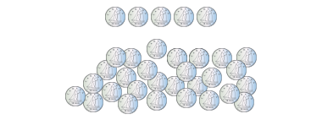  “There’s about 5 groups of 5 dimes, so about $2.50.” | Estimates the value of a mixed collection of coins to the nearest dollar  “I see about 10 loonies and  10 quarters, which is about $12.” | Makes reasonable estimates of mixed collections in dollars and cents  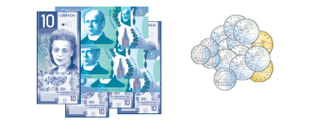  “There’s $55 dollars in bills and about $4 in loonies and quarters.  I don’t think the rest of the coins make a dollar. So, my estimate is about $59 and 50¢.”
Observations/Documentation

