Estimating Money Amounts
Scans quantity of coins (disregards value of the coins)  “There’s a lot of coins.  I think it’s about $100.” | Uses a referent to estimate the value of a collection of one denomination  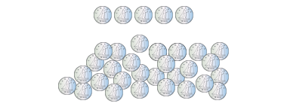  “There’s about 5 groups of 5 dimes, so about $2.50.” | Estimates the value of a mixed collection of coins to the nearest dollar  “I see about 10 loonies and  10 quarters, which is about $12.” | Makes reasonable estimates of mixed collections in dollars and cents  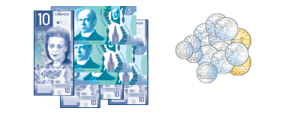  “There’s $55 dollars in bills and about $4 in loonies and quarters.  I don’t think the rest of the coins make a dollar. So, my estimate is about $59 and 50¢.”
Observations/Documentation

