Developing Fluency with Multiplication and Division
Models with concrete materials and counts by 1s | Uses skip-counting forward and backward  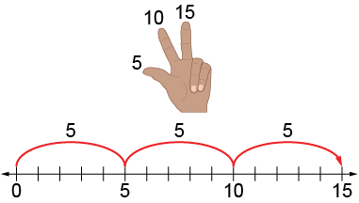 | Works flexibly with numbers (e.g., uses repeated addition or subtraction, familiar facts, commutative property)  “5 + 5 + 5 = 15  I know 2 × 5 = 10 and one more group of 5 is 15,  so 3 × 5 = 15.  I know 5 × 3 = 15, so 3 × 5 also equals 15.”
Observations/Documentation

Developing Fluency with Multiplication and Division (con’t)
Uses distributive property to help with unfamiliar facts  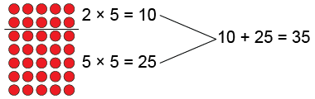  “7 × 5 = 35” | Applies multiplicative thinking to compare quantities (solve ratio problems)  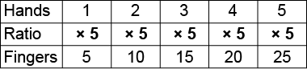  “For each hand there are 5 fingers. The ratio of hands to fingers is 1:5. That means I multiply by 5. So, on 2 hands there are 2 × 5, or 10 fingers.” | Fluently multiplies and divides  “I just know that 7 × 5 = 35.”
Observations/Documentation

