Multiplying 1-Digit Numbers
Groups objects and counts by 1s  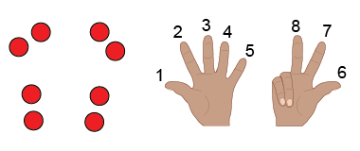 | Groups objects and skip-counts  “2, 4, 6, 8” | Uses repeated addition  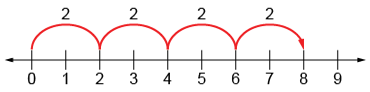  “2 + 2 + 2 + 2 = 8.” | Models using multiplicative thinking  “4 rows of 2 is 8.”
Observations/Documentation

Understands relationship between operations  “I can think of 2 + 2 + 2 + 2 = 8  as 4 groups of 2.” | Uses multiplication symbol  “4 × 2 = 8” | Multiplies fluently (e.g., uses properties of multiplication)  “4 × 2 = 8  2 × 4 = 8” | Creates and solves problems involving equal groups  4 × 2 = 8  “There are 4 bicycles in the shed. How many wheels  are there altogether?”
Observations/Documentation

Dividing 1-Digit Numbers
Models using equal sharing  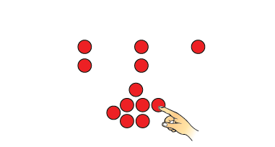 | Models using equal grouping, counting by 1s  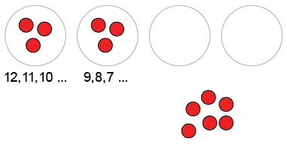  “I know 3 go in each group.” | Models using equal grouping, skip-counting backward  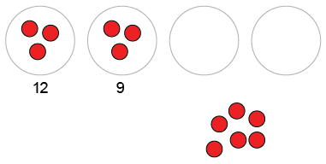 | Uses repeated subtraction  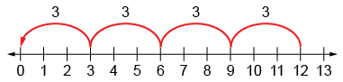  “4 jumps of 3 backward is the same as 12 – 3 – 3 – 3 – 3 = 0.”
Observations/Documentation

Dividing 1-Digit Numbers (con’t)
Models using multiplicative thinking, and uses division symbol  “12 divided into groups of 3 is  4 groups  12 ÷ 3 = 4.” | Divides fluently  “I know 12 ÷ 4 = 3,  so 12 ÷ 3 = 4.” | Creates and solves problems involving equal sharing and grouping  “There are 12 wheels  on tricycles in the shed.  How many tricycles are there? | Understands relationships among operations  “I know 12 – 3 – 3 – 3 – 3 = 0,  so I also know that 12 ÷ 3 = 4.  I also know that 4 × 3 = 12”
Observations/Documentation

