Composing and Decomposing 3-Digit Numbers
Composes and decomposes using tens and ones (one way)  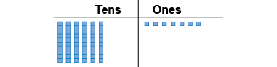  “I modelled 67.” | Composes and decomposes using tens and ones (more than one way)  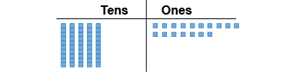  “I traded a ten for 10 ones.” | Composes and decomposes using hundreds, tens, and ones (one way)  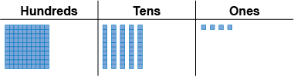  “I modelled 154.”
Observations/Documentation

Composes and decomposes using hundreds, tens, and ones (more than one way)  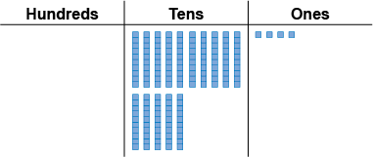  “I traded the hundred for 10 tens.” | Uses place value to write a number in different ways  “One hundred fifty-four  154 = 100 + 50 + 4;  1 hundred, 5 tens, 4 ones;  1 hundred, 4 tens, 14 ones  □IIIII▪▪▪▪” | Understands relationships among digits  “The digit 4 in 429 represents  4 hundreds, 40 tens, or 400 ones.”
Observations/Documentation

Estimating Numbers
Identifies benchmark numbers (multiples of 10)  “23 lies between 20 and 30.” | Compares to benchmark numbers (multiples of 10)  “23 is closer to 20 than to 30.” | Identifies benchmark numbers (multiples of 100)  “123 lies between 100 and 200.”
Observations/Documentation
Compares to benchmark numbers (multiples of 100)  “123 is closer to 100 than to 200.” | Uses benchmark numbers to round 3-digit numbers to the nearest 10  “123 is between 120 and 130, but closer to 120.” | Uses benchmark numbers flexibly to round to the nearest 10 and 100  “123 is between 100 and 200, but closer to 100.  To be more closer, it's between 120 and 130,  and rounds to 120.”
Observations/Documentation

