Decomposing and Composing Quantities
Randomly chooses a number as a part  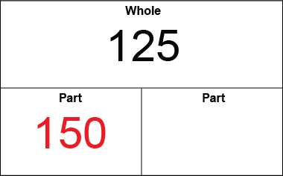  “I like the number 150.” | Finds one part of a whole  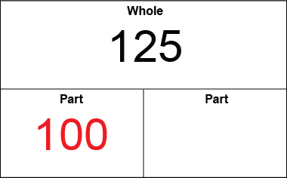  “I thought of a number less than 125: 100.” | Counts on or back to find the other part  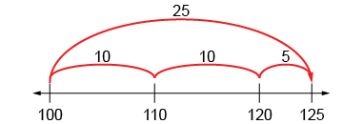  “I counted on: 100, 110, 120, 125;  the other part is 25.”
Observations/Documentation

Composes the whole in different ways using known pairs  100 and 25  50 and 75 | Uses patterns systematically to compose the whole, considering 0  “I kept taking 1 from a part and  giving it to the other.” | Uses number relationships and mental strategies to compose the whole  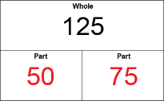  “75: I know 50 and 50 make 100, and 25 more makes 125.”
Observations/Documentation

